Caraway: Mental Health Resources for College Women

Group 7

Ada Pici, Charlotte Andry, Hina Khalid, Safiya Mustafa



Table of Contents

[**1** Design Problem](https://docs.google.com/document/d/1uMIPxwmK2yCJp2Eghl-V1UjVdsxb4QS8/edit#heading=h.gjdgxs) 5

[**2** User Research Planning](https://docs.google.com/document/d/1uMIPxwmK2yCJp2Eghl-V1UjVdsxb4QS8/edit#heading=h.30j0zll) 5

[**2.1** Focus Setting](https://docs.google.com/document/d/1uMIPxwmK2yCJp2Eghl-V1UjVdsxb4QS8/edit#heading=h.1fob9te) 5

[**2.2** Discussion Guide Creation](https://docs.google.com/document/d/1uMIPxwmK2yCJp2Eghl-V1UjVdsxb4QS8/edit#heading=h.3znysh7) 5

[**3** User Research: Focus Groups/Interviews](https://docs.google.com/document/d/1uMIPxwmK2yCJp2Eghl-V1UjVdsxb4QS8/edit#heading=h.2et92p0) 6

[**3.1** Recruitment Process](https://docs.google.com/document/d/1uMIPxwmK2yCJp2Eghl-V1UjVdsxb4QS8/edit#heading=h.tyjcwt) 6

[**3.2** Participants](https://docs.google.com/document/d/1uMIPxwmK2yCJp2Eghl-V1UjVdsxb4QS8/edit#heading=h.3dy6vkm) 6

[**3.3** Focus Groups/Interviews](https://docs.google.com/document/d/1uMIPxwmK2yCJp2Eghl-V1UjVdsxb4QS8/edit#heading=h.1t3h5sf) 7

[**4** User Research Data Analysis: Affinity Diagramming](https://docs.google.com/document/d/1uMIPxwmK2yCJp2Eghl-V1UjVdsxb4QS8/edit#heading=h.4d34og8) 7

[**5** User Research Data Analysis: Walking the Data](https://docs.google.com/document/d/1uMIPxwmK2yCJp2Eghl-V1UjVdsxb4QS8/edit#heading=h.2s8eyo1) 9

[**6** Design Artifacts: Personas, Scenarios, and Storyboards](https://docs.google.com/document/d/1uMIPxwmK2yCJp2Eghl-V1UjVdsxb4QS8/edit#heading=h.17dp8vu) 10

[**6.1** Persona](https://docs.google.com/document/d/1uMIPxwmK2yCJp2Eghl-V1UjVdsxb4QS8/edit#heading=h.3rdcrjn) 11

[**6.2** Scenario](https://docs.google.com/document/d/1uMIPxwmK2yCJp2Eghl-V1UjVdsxb4QS8/edit#heading=h.26in1rg) 12

[**6.3** Storyboard](https://docs.google.com/document/d/1uMIPxwmK2yCJp2Eghl-V1UjVdsxb4QS8/edit#heading=h.lnxbz9) 16

[**7** Task Analysis and Task Flow Diagram](https://docs.google.com/document/d/1uMIPxwmK2yCJp2Eghl-V1UjVdsxb4QS8/edit#heading=h.35nkun2) 17

[**8** Wireframe Flow Diagram](https://docs.google.com/document/d/1uMIPxwmK2yCJp2Eghl-V1UjVdsxb4QS8/edit#heading=h.1ksv4uv) 19

[**9** Responsive Wireframes](https://docs.google.com/document/d/1uMIPxwmK2yCJp2Eghl-V1UjVdsxb4QS8/edit#heading=h.44sinio) 21

[**10** Early Design Feedback](https://docs.google.com/document/d/1uMIPxwmK2yCJp2Eghl-V1UjVdsxb4QS8/edit#heading=h.2jxsxqh) 28

[**10.1** In-Class Critiques](https://docs.google.com/document/d/1uMIPxwmK2yCJp2Eghl-V1UjVdsxb4QS8/edit#heading=h.z337ya) 28

[**10.2** Next Steps](https://docs.google.com/document/d/1uMIPxwmK2yCJp2Eghl-V1UjVdsxb4QS8/edit#heading=h.3j2qqm3) 28

**11** Low-Fidelity Prototyping and Testing 28

**11.1** User Feedback on Low-Fidelity Prototype 29

**11.2** Resulting Design Changes 29

**12** High-Fidelity Prototyping and Testing 30

**12.1** High-Fidelity Prototype 30

**12.2** Implementing Design Changes Based on User Feedback 32

**13** User Testing 33

**13.1** Participants 33

**13.2** Method 33

**13.3** Findings 35

**13.4** Design Changes 35

**14** UI Implementation 41

Appendix A: Discussion Guide 43

Appendix B: Transcripts and Signature Sheet 45

Appendix C: Affinity Diagram 49

Appendix D: Annotated High-Fidelity Prototype 51

Appendix E: User Testing Script 55

Appendix F: Data Logging Sheet 57

# 

# Design Problem

One topic that has been talked about more recently is mental health. People are realizing how much it can affect your day to day life, along with how important it is to be aware of it. For college students, school is a common source of stress. Even though we’re learning more about how to handle stress, many students don’t have the resources they need to handle their stress in healthy ways.

Caraway is a start-up company designed to help meet this need for college women. They strive to provide access to different medical professionals through their app while also helping with setting up virtual appointments, making it easier for students to get the help they need(Home. Caraway, <https://www.caraway.health/>).

Through our research we found that many college women would take advantage of mental health resources if they were accessible and affordable. Giving them the opportunity to find help in this way can help improve their mental health and the way they deal with stress.

Caraway will have an immediate impact on college-aged female students, however, there will also be people who are impacted indirectly. The users’ families and friends will see a change in their interactions with the user. When your mental health has improved, it affects not only you, but those you come into contact with on a regular basis.

# User Research Planning

We’ll begin talking about User Research Planning, and what went into our planning process. We’ll talk about preparing for the discussion, what tools we made use of, and how we determined which questions would be good to ask in order to help us solve our problem statement. By the end of this section, we’ll have our completed discussion guide, which we will then use for our focus group.

## Focus Setting

When doing a focus group, it’s great to have a comfortable focus setting in order to set the mode and the comfortability for your participants. Focus setting isn’t just about the physical space, but the feeling between volunteer and facilitator. When you do focus groups, you may ask your volunteers to get a little vulnerable in order to get more useful information. It’s good to have a closed off space, so that the volunteers feel like what they share will stay within the space you’re in.

Our discussion was held over Zoom. Volunteers were in a setting of their choosing, so we needed to make sure that the feeling between facilitator and participant was comfortable through zoom.

## Discussion Guide Creation

A discussion guide is a tool used by facilitators to help guide them through their discussion with their focus group participants. The guide is meant to have questions that guide the facilitators to answers to their problem statement. It’s not meant to be a script, read word for word, but just keep the focus of your discussion so that you can get all the answers you’re looking to hear about.

When creating our discussion guide, we went through a process of first, coming up with a list of questions that would help warm up the participants to each other. These questions would be related to our topic, but on a very basic level, questions that could be answered factually, and didn’t require too much thinking behind them. After we had those questions brainstormed, we thought about questions that would help our participants think deeper about stress and how it affects them. We needed to make sure that these questions were thought provoking, but also that they would stay on topic. In addition to brainstorming these questions, we also brainstormed follow-up questions, in order to keep the conversation flowing. At this point, we had more questions than we needed, so we went through our questions and chose the ones that would best lead us to solutions to our problem statement.

Mental health is such a broad topic, so we knew that we would need a discussion guide in order to help us stay focused on our specific problem we’re trying to solve. To get us started, we had every participant list off their name, gender, age, year/major, and one way they like to handle stress. This helped with introducing everyone to each other before warming up with light questions related to our topic of discussion. To help set the comfortability of the focus setting, we asked warm-up questions related to our main topic, such as “What are ways you like to make sure you don’t burnout or get over worked?”. This led us into our discussion without jumping in too deep. When it was time to get into our main discussion, we had to be wise about what questions we asked. We knew that we didn’t want to ask direct questions about our implementation. We wanted to ask questions that would allow us to really get a feel for their dream application, and find a way to have that be our interface. Nothing like, “If you had your own website for therapy, what would it have looked like?” That’s too straight forward of a question. That wouldn’t allow us to go deeper into understanding their needs. Instead we asked things like “How much does your education contribute to your stress?”, and “Tell us about a time you felt the most stressed.”. Questions like these helped us draw out answers to our problem statement from our participants.

# User Research: Focus Groups/Interviews

We’ll now begin talking about the actual focus group, how we chose our participants, where we conducted our focus group and things that went well. This step in our design process proved to be very crucial, as we would need this collected information in order to determine our user needs.

## Recruitment Process

Caraway’s target users are college women looking for mental health resources and therapists. We hope to find therapists and medical professionals at a more affordable rate. In order to determine what our users need, we decided to hold focus groups that could speak to college women’s experiences with stress.

In order to find participants, we reached out to friends at UIC, and other schools, in hopes of finding people with availability within the timeframe we needed. Some were available for only part of our focus group, but most were able to stay for the whole time.

Challenges we had when recruiting participants was finding a time that worked for all of us to meet together to hold this discussion in person. We couldn’t find a time where the number of participants would have met the requirement, so we decided to hold our focus group over Zoom. This allowed us to have the most participants together at one time. In total we were able to have 7 participants.

## Participants

In total, we worked with about 7 participants, all women in college. Our participants varied in major, year and experience with therapy. Most students went to UIC, but we also had a participant from Loyola University. All of our participants agreed that their main source of stress came from school, and how much of a load it included compared to other responsibilities. We knew that most students in college would, so we weren’t worried about choosing people to participate who didn’t struggle with stress management.

## Focus Groups/Interviews

Focus groups are a type of user research where you conduct a conversation towards a group, instead of an individual. They’re conducted so that you can get first hand information about a problem you’re trying to solve, or about a product you’ve created. With our research, we were hoping to learn about stress amongst students. What causes it, how students handle it, how they try to prevent it, what they do when they experience it, who they talk to, etc.

We only needed to conduct a singular focus group, that lasted about an hour, to be respectful of our users’ time. During our time, we asked users to be honest, to share what they wanted in order to get honest opinions. We welcomed the participants to build on each other's answers, and converse amongst themselves, if they felt comfortable doing so.

We needed to record our focus groups, and thankfully Zoom already has that functionality. We made use of the screen recorder in Zoom, and told participants, if they were uncomfortable, to turn off their cameras throughout the duration of the recording. Additionally, we only need 1-2 facilitators to actually conduct the conversation, so the other facilitators were note takers. After the recording was finished, one facilitator transcribed the audio manually.

Something that worked well during the focus group from a logistical standpoint was focusing on stress management tools. It was easy for the participants to talk about what they actively did to manage in times when they were stressed. However, if we were to do this again, we would have a long time frame so that we could conduct this focus group in person. Conversation flows much easier when you’re in-person versus when you’re over Zoom, especially with people you don’t know.

# User Research Data Analysis: Affinity Diagramming

Next, we’ll begin talking about what affinity diagramming is, and how it helps us in our design process. We’ll look into what tools we use, and what we find from analyzing our responses from the focus group.

An affinity diagram is a process in which you can organize information into different groups. It’s used to prioritize important information after brainstorming. We used it to analyze our information after doing our focus group. We got lots of responses and eventually needed to identify user needs from these responses.

In order to do our diagramming in an efficient way, we made use of Google Jam Boards. This allowed us to keep our findings neat and color coded. We first typed out all of our responses from our focus group participants. Once everything was typed out on its own post-it, we collected similar responses together by groups, no matter how many groups we had. Based on these created groups, we try to give them headings. Once we had headings for all of our groups, we found commonalities within which some headings would coincide. A lot of headers coincided with how students handle stress, whether in a healthy way or not. Some themes included how students may share their stressors with others, but the people give unhelpful insight or comments.

Some things to keep in mind when it comes to doing affinity diagrams, is that you will most likely end up with a lot of sub headings/groupings. This isn’t something to worry about, it will be nice in the end, because you’ll have identified many user needs that will help you in your design process. You’re encouraged to see how these groups work together/if they do so.

We had 5 themes to focus on in total at the end of our affinity diagram. The first one being how our users deal with stress. We had multiple different subheadings under this theme related to dealing with stress by distracting one’s self, through over-consumption, and through calming activities and hobbies. Our second theme focused on the fact that many of our participants receive useless insight. They’ll share their stressors with people who are close to them, but wouldn’t receive tips or help in a way that was sensitive to their mental state, not helpful as far as getting rid of the stressor. The third and fourth themes were related to each other: a preference for therapy, and not needing therapy. The first one focused on what people look for in a therapist that would make them feel comfortable seeking advice from them. The second one focused on how our users get by without a therapist, and why they choose to stay away from therapy outside of cost logistics. Our last theme was related to the fact that education causes college-women the most stress. We saw an extreme need for balance between school and the other responsibilities in their life.

~~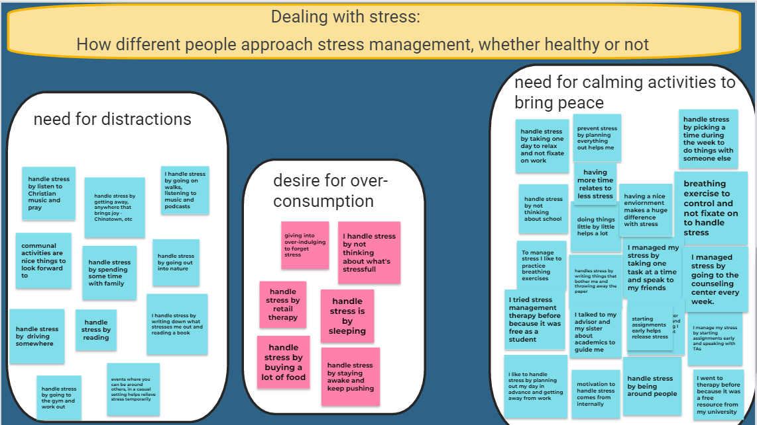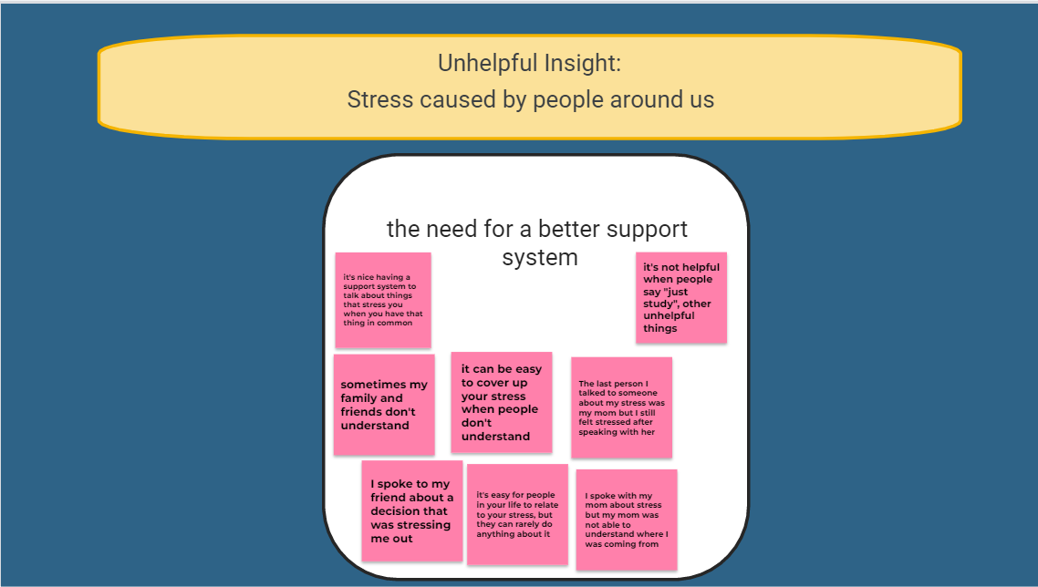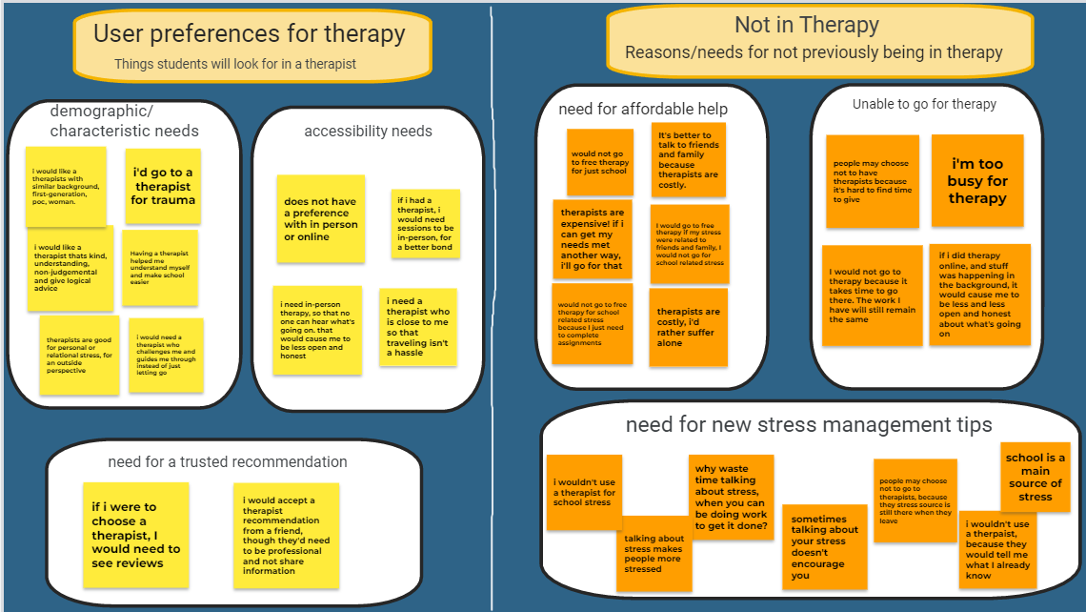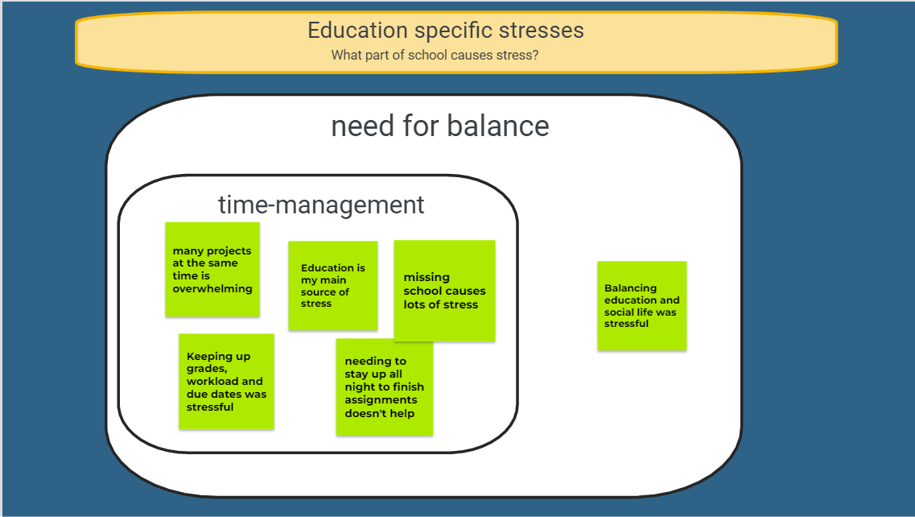~~

# User Research Data Analysis: Walking the Data

This section will talk about how we “walked” our data, and how we analyzed our findings in order to extract user needs. This can be a very long process, so it will be broken down by theme in order to stay cohesive.

“Walking the data” means to analyze your findings and see the most important issues that arise from what you find. It’s done to better understand and filter your data after diagramming it out. From here, your goal is to know what your users care about, what they have problems with within your interface, etc. In order to “walk” through our data, we identified what users cared about, pain points, design opportunities and holes within each theme.

First, we’ll address the theme, “Dealing with stress”. We found that users care about calming situations and things to do to take their minds off whatever is stressing them. Additionally, they care about hobbies or something they find entertaining to take away from their regular stress. A pain point was that users don’t want to spend too much time on these hobbies since they might cause problems with their workload and lead to more stress. We found that it needs to be a quick distraction. We found a couple of holes within this theme. A question we wished we could’ve asked was “are these stress management methods helpful?”, “What are unhealthy ways you deal with stress, which may not be something you wanna share about, but may be more accurate?”, and more. We needed to clarify if users want these fun/calming activities offered on campus or elsewhere. Asking questions around these would have proven to be helpful in addition to what we had. We found a couple of design opportunities coming out of this, like implementing calming exercises within our application. We found it could help to have a menu option which includes different activities that are offered to help them destress.

Next, we’ll talk about the second theme, “Unhelpful Insight”. We found in this theme that users really cared about being surrounded by people that can offer them support or just be there to listen to what they are going through. These people don't necessarily have to decrease their workload or directly influence their work, but give them peace of mind and/or helpful tips. Some user pain points that were identified were being able to have a reliable support system in their life that listens and understands them when it comes to stress. However, some users felt that this kind of support wouldn’t be useful since it doesn't really decrease their workload. Within this theme, we wished we could’ve asked questions about how frequently they would want the therapy sessions, and the opportunity to vent. We also could’ve asked questions about what the users felt they needed from people around them to help them succeed, and what was lacking. Despite not asking these questions, we were able to get some design inspiration from what we analyzed. We figured the design could have the option for people to give feedback on how exactly people around them can help. We figured we could also have the option to let people bring in their close family or friends to the sessions so they can also be guided better or how they can support the students and help them destress.

Next, we’ll look at the third theme, “User Preferences For Therapy”. Our participants showed us that a couple of things that were important to them when choosing a therapist was having one with a similar background, and the ability to give constructive feedback. Our users also wanted to have the option between in-person/online, and a recommended therapist from a family or friend. A pain point when it comes to finding a therapist is finding a reliable and trusted one, especially when you’re looking through a list of thousands. Something that would’ve been good to ask is “What are some reasons users would use therapy?”, and “How often do they feel they would need it?”. With the information we did have, we were able to come up with a couple of design opportunities such as our users being able to see reviews of each therapist. Another thing that would be good is being able to book online/in-person therapy sessions. Basically, knowing background information for a therapist before booking a session.

We’ll now look at the fourth theme, “Not in Therapy”. We found that users care about getting therapy in an affordable and convenient way. It needs to be offered in a way that doesn't increase their stress. Getting therapy in this way can have the opposite effect on the students and further increase their stress. When analyzing pain points, most students spoke about not being able to afford therapy and how they would only go if it was free of charge. Now, actually helping this would require getting a grant or finding therapists that are willing to volunteer and offer free therapy sessions. We found that most students will not be able to commute to the therapy session locations and might need to attend it virtually or on-campus. We did find holes in our data in regards to this theme as well. Users still need to clarify on how many sessions they will have (how frequently) and if they are willing to have group sessions so that way more students will be able to attend a therapy session even though it won't be a one-on-one session. This will, however, allow us to keep therapy sessions free or affordable. We figured when going about designing our interface, we could include an option to have virtual sessions for students that have an issue with commuting. We can also include an option to opt in for group sessions.

Lastly, we’ll look at the fifth theme, “Education Specific Stresses”. We found that our users find it important to have good time management. For example, more time to complete their responsibilities, being able to do one thing at a time, having less of a course load and how much work they take on. They want to be able to balance social life with education. They care about their education, but also doing it in a way that doesn’t affect them mentally. Some pain points we found amongst our users was that there tends to be too much work, no play. The fact that they still have to go to school when responsibilities aren't done and need to be is a big thing. Most students even have multiple things to work on at one time because of due dates. We would’ve wanted to ask things surrounding what other sources of stress they have, whether within their personal life or not. It would’ve been nice to explore what helps them navigate that. With all this information we found, we thought it would be nice to include a calendar or time management tips.

After “walking” through our data, we were able to determine 5 user needs. User Need #1 was a support system consisting of productive conversations around stress and stress management. User Need #2 was identified as affordable/free and convenient therapy sessions. User Need #3 turned into having hobbies where the student would healthily decrease stress. User Need #4 was the option to have in-person or online therapy sessions. Lastly, User Need #5 was the ability to see reviews for therapists.

# Design Artifacts: Personas, Scenarios, and Storyboards

This next section will focus on our design artifacts that help progress the design process outside of just the digital work. We worked with and created personas, scenarios, and storyboards to help with our understanding of how our interface will impact the users. With these tools we were able to take into account factors we hadn’t considered before.

## Persona

A persona is a fictional user whose personality and characteristics are made up, based on real data collected about users. It can help in the design process, because you’re keeping in mind who it is you’re designing for. You’re using that data you’ve gathered from your focus groups, and the needs that you’ve identified, and can now cater it more towards your target users.

When creating your persona, first you want to identify common and important characteristics within your participants from your focus group, and from your target audience. You consider things like background, lifestyle, responsibilities and other things, not only as it relates to your product and its use. You consider what their weaknesses and strengths are, along with their goals. We also want to know what their life looks like without the product we’re creating for them. We want to know how they function without it, so we can see how our product will help.

We created three different personas based on the information we gathered from our user research. First, we created Jaleesa, who is a full-time STEM student who also works part-time. Jaleesa is one who struggles with anxiety, as she has a lot to balance in addition to school and work. We know that when she gets stressed she likes to listen to music and read, but she would rather have someone to talk to about her problems with having balance in her life. For Jaleesa, we were able to identify some motivations, needs and ideal features for our interface that could help make her life a bit easier.

We then were able to create Amy, who also is a fulltime STEM student that works part-time. She really wants to achieve more scholarships so that she doesn’t have to worry about paying for school but that isn’t working out for her right now. She has high expectations for herself because of this, and has much financial stress. Ideal features for her in our interface would be stress management exercises that she can do when she feels anxious, or overwhelmed. She needs free or affordable therapy, so keeping that in mind will be important as well. Amy will be our focus persona, as we really want to make sure we include options for finding affordable therapists, but also providing stress management tips that people can take on the go.

Our last persona was Sara Don. She’s a full-time student who also works part-time, but on campus, where the pay is lower than normal. Sara’s family is abroad, and she’s in school in the US all alone. It’s been harder for her to make friends, since she is an international student, but chooses to work hard. She loves going to different events hosted by student organizations in order to meet people, though her schedule is already packed. She’s struggling with her course work, and it doesn’t help to be so far from family. She would love a therapist, but knows they can be expensive.

Both Sara and Jaleesa would be considered our secondary personas, because they both struggle with different things that we’d like to take note of in our interface. Though, Sara’s problems are where we want our focus to be. All of these personas were made based on the participants and common struggles and motivations they had. The combination of things they struggle with are different, but all important to take note of as we go about the rest of our design process.

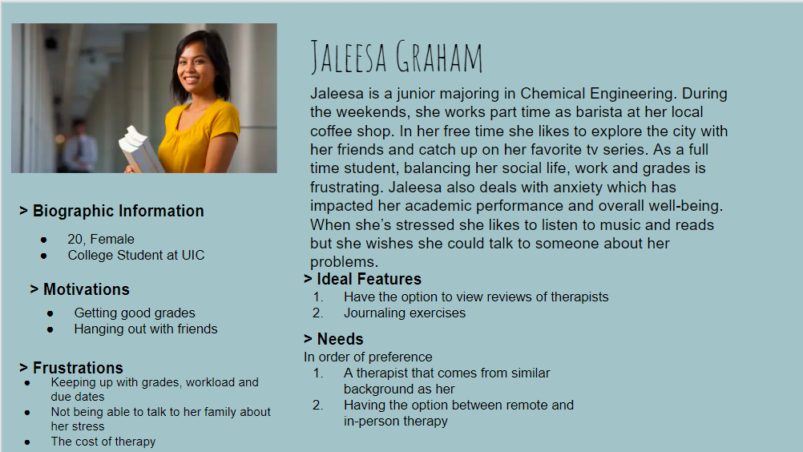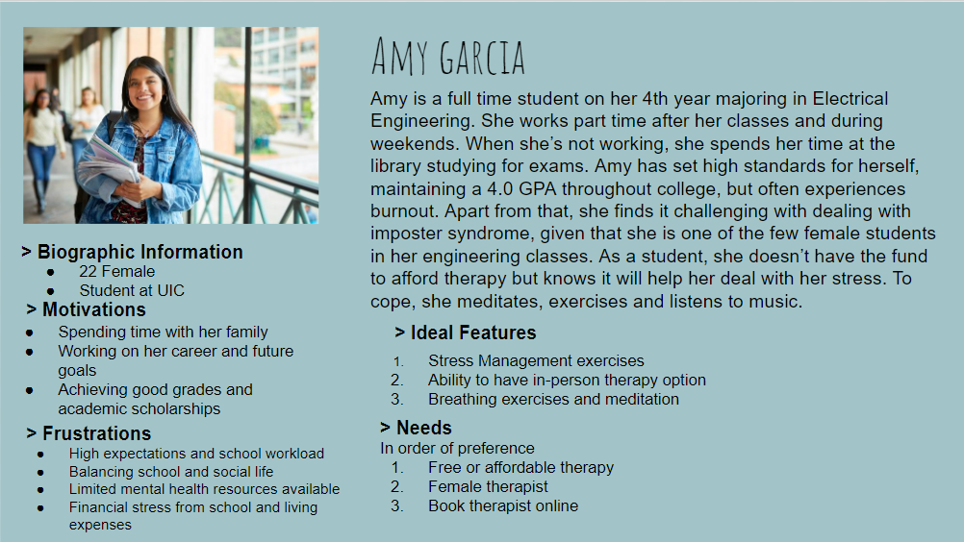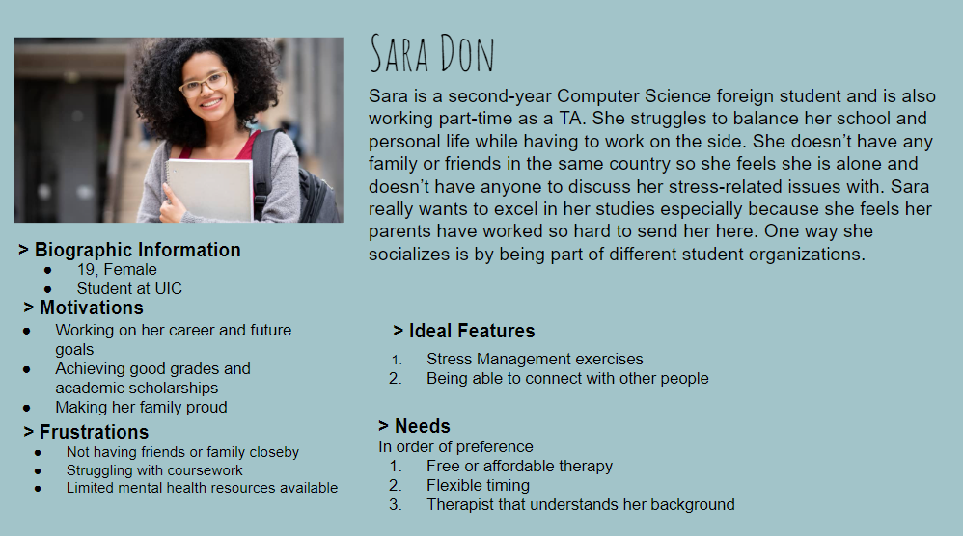

## Scenario

Scenarios are a great way to get a bit more specific when it comes to your personas. Giving them more life than just their profile. We get to look at a day in their life when we create scenarios, and see what their life is like with our interface. We’ll be looking into a singular example of the users using our product.

When creating a scenario, you think about what people will want to achieve when coming in contact with your interface. You think about how they will achieve it, and even what things can help them within the design of your interface. It’s good to come up with key tasks that your interface needs to be able to complete. We came up with four different key tasks:

1. Find stress management tips
2. Explore a list of calming hobbies and activities to try
3. Look at list of reviews and contact info of therapists
4. Call a therapist for the chance to set-up recurring meetings

From these key tasks, we were able to create some scenarios in regards to our three personas.

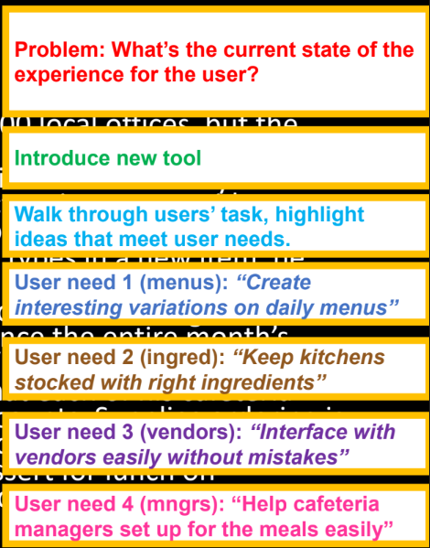

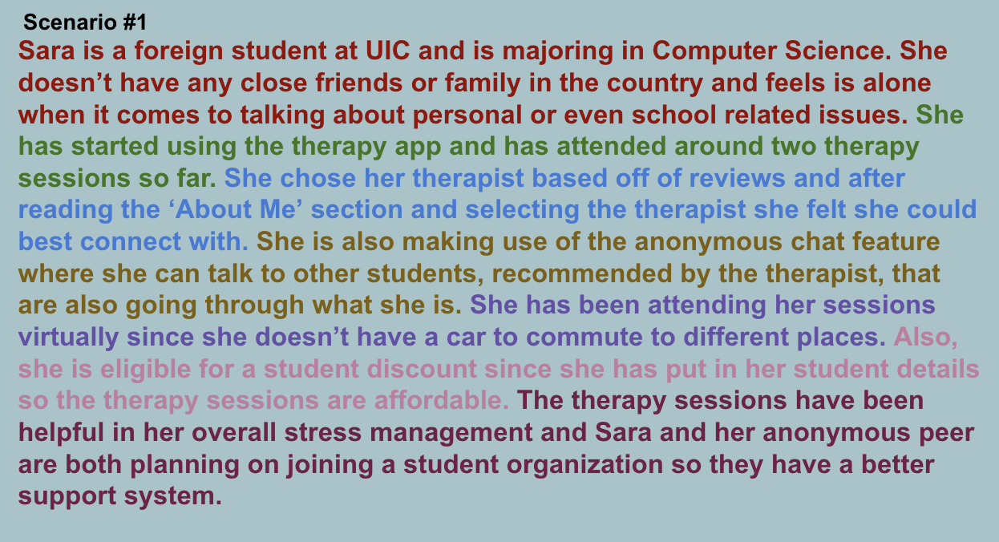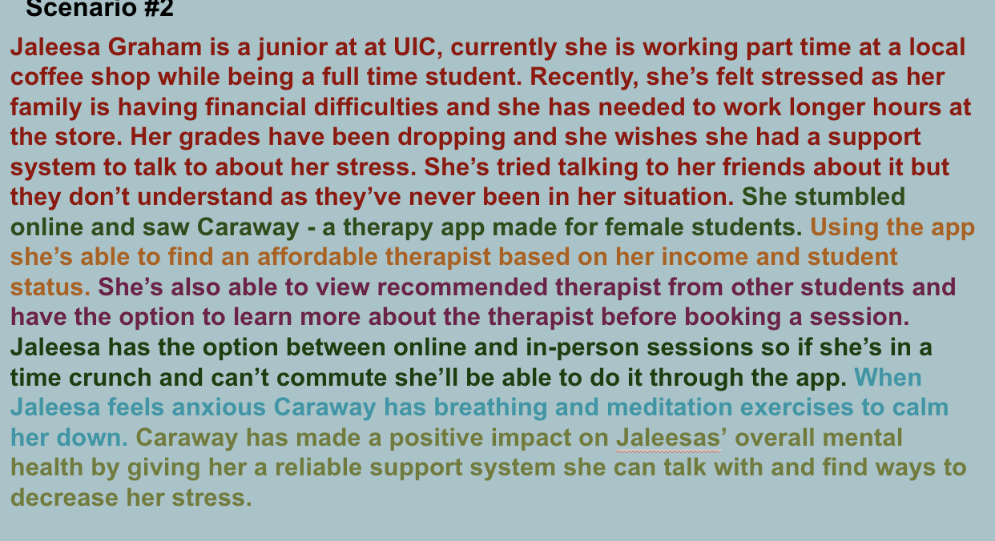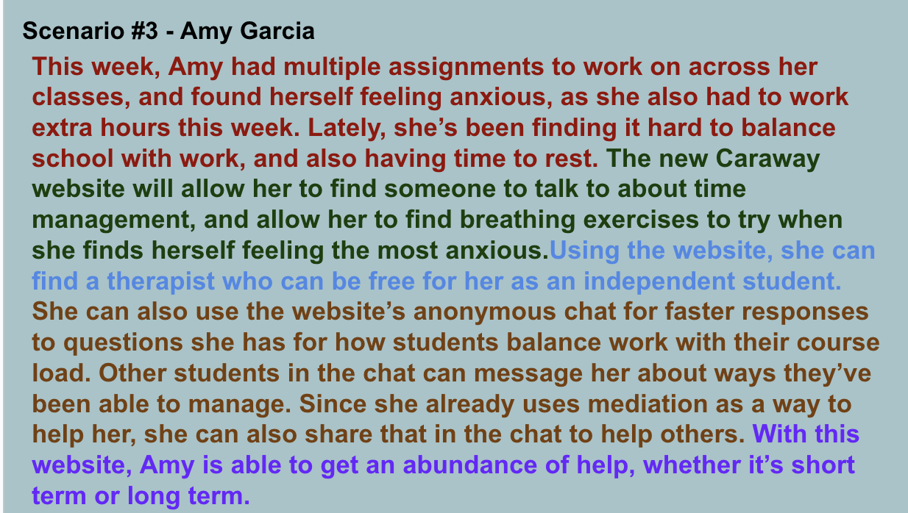

## Storyboard

Storyboards are visual scenarios. They show both the interface and the user in the context of the interface actually being used. It can be visualized as a comic-strip, where each scene is a different step in the story. It helps in the design process, because it considers the elements of the physical context, things you may not consider when only designing digitally. Something that is important to emphasize when it comes to storyboards is the scenes, these should be able to stand on their own without explanation.

We were able to create a storyboard for each persona created.

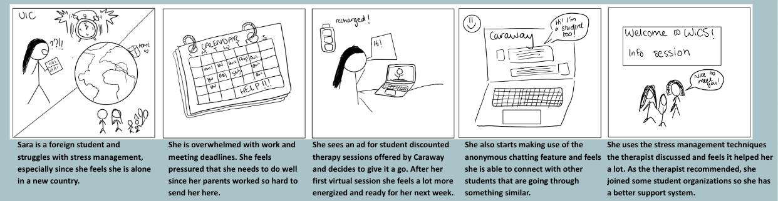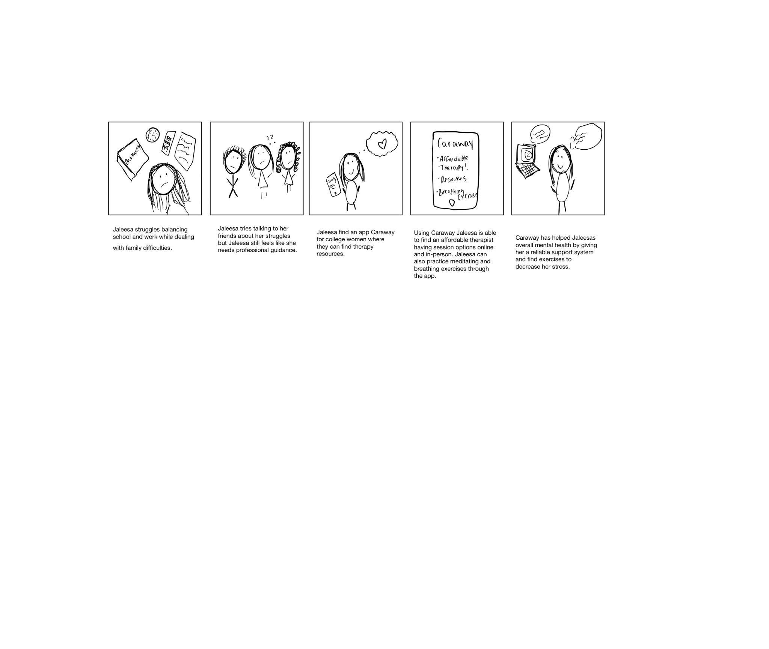

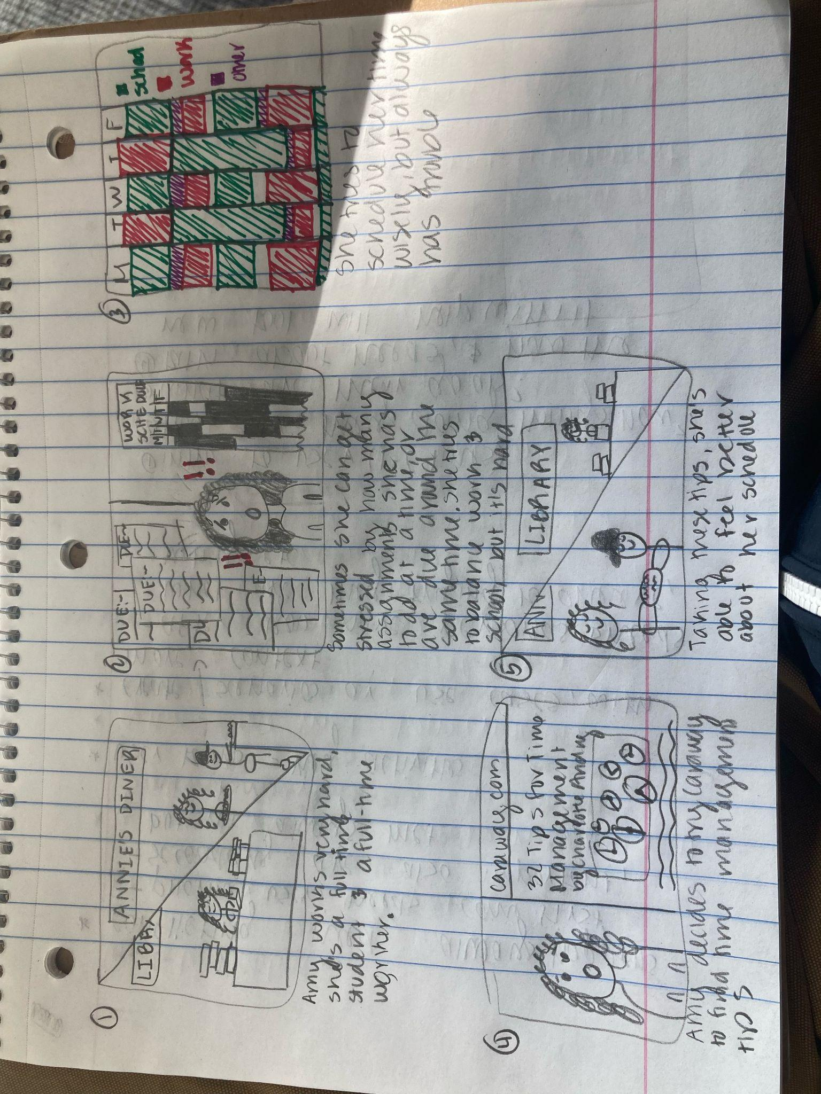

**First Box:** Amy works very hard. She's a full time student and a full time worker.

**Second Box:** Sometimes she can get stressed by how many assignments she has to do at a time or are due around the same time. She tries to balance work and school but it's hard.

**Third Box:** She tries to schedule her time wisely, but always has trouble

**Fourth Box:** Amy decides to try Caraway to find time management tips.

**Fifth Box:** Taking these tips, she’s able to feel better about her schedule.

# Task Analysis and Task Flow Diagram

Next, we will be discussing our process of determining the flow of our interface. We made use of flow diagrams to see how far a user would need to go to achieve basic functionality, based on the key user tasks mentioned before.

A task analysis is a way to represent and create a conceptual model. The tasks will be a list of activities that your interface will need to support so that users can fulfill their needs. Based on our 4 key user tasks we created, we made flow diagrams based on how users will navigate to the pages that help them fulfill these tasks. Flow diagrams make use of decisions and processes in order to determine how an outcome will be achieved. This process proved crucial to know how our interface would flow between different pages, and show us how deep a user would need to go into our interface before finding what they needed.

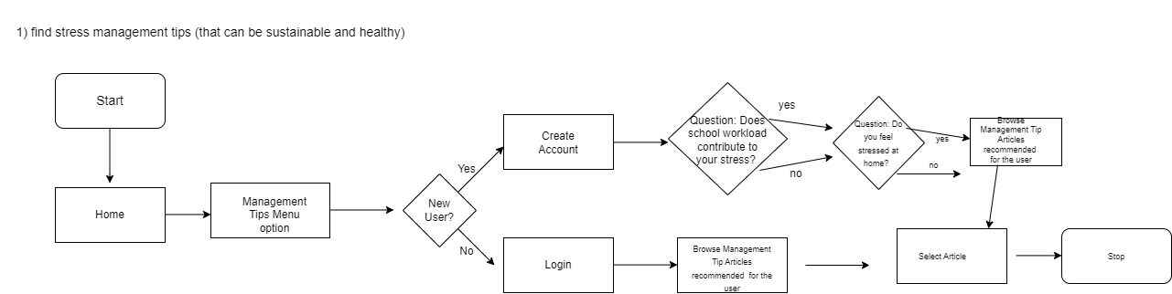



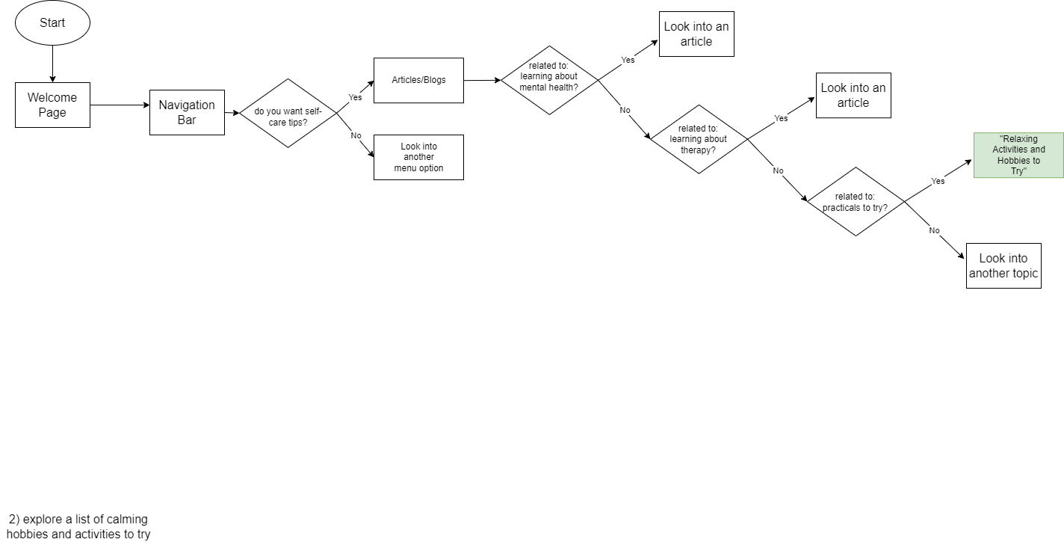

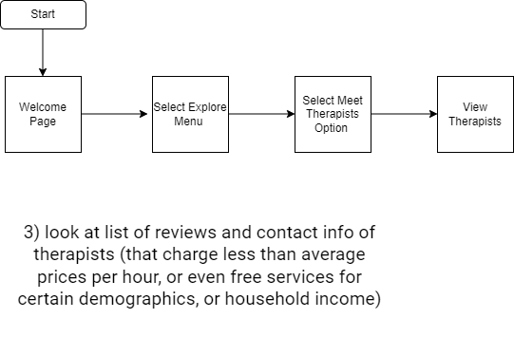



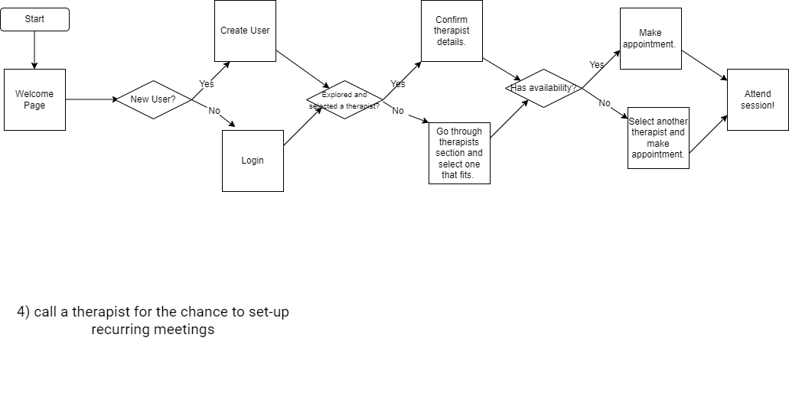



# Wireframe Flow Diagram

This next section will talk about wireframe flow diagrams, and how they differ from task flow diagrams. Most of the work done here was built off of our task flow diagrams, but there are ways in which they differ.

A wireframe flow diagram takes your task flow diagram, and adds in web pages for them, as a draft for your interface. It’s different from the task flow diagram, because it gives a look at our flow process. It isn’t a complete wireframe, but gives enough context to show where we’re going in our design.

For this process, we continued using diagrams.net, as we did for our original flow charts. We started by creating a wire frame representing each process block in our diagrams, leaving only the decision blocks as the same. When creating the wireframes, the main choice we made when designing was between having all information out in the open, versus a more minimalistic look. We decided to choose the hamburger menu for our final design choice, in order to keep all of our menu options tucked away until needed. This gave a clean look for our final design, but also made things easy to access as far as our navigation bar.





User Need #1 talks about finding stress management tips. We decided that they also needed to be sustainable, so that the users can come back to them when they’re needed, and healthy, so that they’re not just bottling them up, and not dealing with the stressors. Management tips will be one of our menu options, so that the users can have quick access to them, and not have to dig too deep to find them. They’ll be asked to log in when accessing these articles, but there will be many to look into, depending on their need or desire.



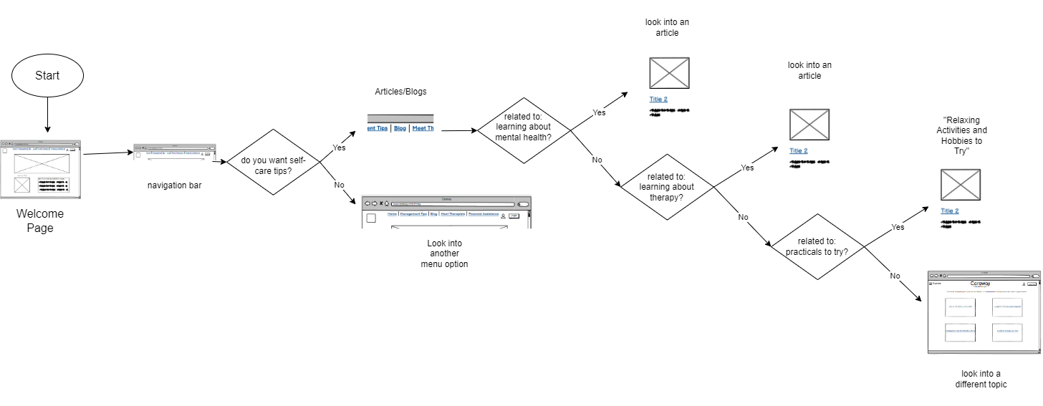

User Need #2 was the desire to explore a list of activities to try and hobbies to take on to help deal with stress. These tips can be found under our blogs page, where there will be multiple topics to find information and activities under. There will also be many more articles to access depending on your need.



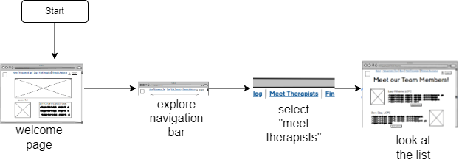

User Need #3 talks about the need to look at reviews for therapists, so you can know more about who you’re choosing to be open with. This will also be a navigation bar option, so that users can have quick and easy access to this. This is one of our primary needs.



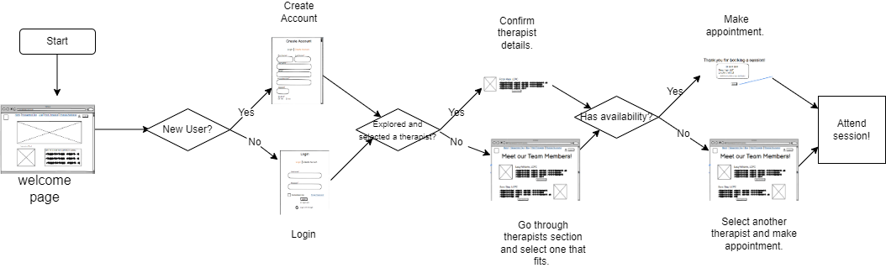

User Need #4 works with the ability to set up appointments with the therapists they find. Users will need to log in for this option, so that we can send information to the therapists, when they set up an appointment.

# Responsive Wireframes

Designing responsive wireframes using HTML and CSS gave us the ability to view our web pages in a test environment and practically see our key features being used by users. This gave us a deeper understanding of how some features can be maximized and developed in a way that increases their efficiency.

**9.1** Need for Responsive Wireframes

We were able to identify mandatory and optional content sections for each page that we developed. Since our web page is supposed to mainly cater to users coming into making appointments with therapists, the page needs to appear professional and also give a sense of comfort where features and appropriate suggestions and feedback are easily accessible.

**9.2** Annotated Responsive Wireframes

Homepage (desktop screen):





Homepage (iPhone XR screen size):





Did not change header and footer.

Changed 2.3 review description in hero. It is under the image instead of being beside it.

Homepage (iPad Air screen):



Did not change header and footer.

Changed 2.3 review description in hero. It is under the image instead of being beside it.

Login Page (desktop screen):



Login (iPhone XR screen):





Did not have to change any components.

Login (iPad Air screen):





Did not have to change any components.

# Early Design Feedback

Early Design Feedback is the process of gathering feedback on a design during the early stages of a project. For our early design feedback, we seek feedback from our classmates. The goal of early design feedback is to identify design areas of improvement from the wireframes created. Collecting constructive feedback during the early stages of the design process ensures that user needs are met and we can incorporate the feedback early on before building the final product. The output of in-class feedback is verbal and written comments with suggestions on our design ideas and features from classmates we presented our project to.

## In-Class Critiques

During in-class critiques, our group presented a slide presentation to two other groups. Our slideshow showed our design problem, user needs, task-flow diagram, wireframes and alternative design solutions. We received feedback from 7 other students, the top pieces of feedback we received were:

1. “I think both the navigation bar as well as the "Meet our Team Members" page are both very well designed with regards to what the user would use and need at a quick notice. I think throwing the social media into a footer with other information rather than having it more of a bar at the bottom of the screen.”
2. “I think everything was very verbose and logically flowed well. Met all expectations of what we thought of in the app. I think the login flow user experience could be improved to allow for users to onboard more quickly and be less put off by requiring so much information right off the bat”
3. “ I really liked the questionnaire had the questions split between different pages to avoid clutter. At the end of the questionnaire, maybe put a button at the bottom to return to home so that the user is not confused on whether or not they have reached the end.”

## Next Steps

* + Planned Change #1: For feedback #1, we plan to make our footer bigger and more visible with information such as information about us, contact, and our social media links.
  + Planned Change #2: For feedback #2, we plan to have our login page only ask for the username and password. We also plan to let the user go back to the sign-up questions when creating an account so the user can make an account faster.
  + Planned Change #3: For feedback #3, we plan to add a button at the end of the questionnaire so the user can return to the home and have a progress bar so the user can see how many questions the user has left.

# Low-Fidelity Prototyping and Testing

Low-fidelity means that it does not look that close to what the final product would look like. We do this by walking through the steps of the interaction, helped by a facilitator who knows what happens when an action is taken on each screen. Initially we used paper sketches of low-fidelity prototypes that are not pixel perfect wireframes. Then based on those paper sketches we created interactive low-fidelity interactive prototypes by using inVision Application. Following is the link to the interactive low-fidelity prototype: [Interactive Wireframe](https://projects.invisionapp.com/share/NX136K6EE93Z#/screens/472294497_Home)

## User Feedback on Low-Fidelity Prototype

In order to get user feedback on our Low-Fidelity prototype we recruited three university students. We provided them with the low fidelity prototypes and asked them to interact with it. One of our team mates acted as a facilitator to help the user interact with the prototype . The facilitator observed the user and when he or she tried to interact with a part of the prototype, the facilitator made the necessary adjustments and navigated them. The users were asked to do the following tasks: Create an account, find time management tips, look into different therapists and find information on the “Family Discount” for therapy. Users were also asked to talk through their thought process when performing different tasks. With the facilitator user interacted with the prototype in a much convenient way. During the testing session taking notes went very well. Also, using the script and document to ask user questions or tasks were very helpful. Something that didn't work very well was navigating through pages as it was low fidelity prototypes. Users faced difficulty in the login/create an account page. The reason was because the login/create account page had a lot of information required to be filled in. One of the users said “Not clear where to navigate to create an account”. One other user said “Having too much information to give, not clear to scroll down to add more info”.

## Resulting Design Changes

Following are some of the resulting design changes based on the user feedback:

#1. There was initially a button with label “Login” and another user icon button for account creation which confused the user which button to click in order to login so based that we removed the user icon button.

#2. Since users were confused about the login process, we removed the user icon button so we added the create account part to the login part in order to remove confusion and make it simple.

#3. Account creation had a lot of information to fill in and users were confused if they should scroll down so based on that we made it simple by having some information to fill in on one page and some on the other and we also removed the unnecessary fields.

#4. Initially once the user creates an account they are directed to the Home page. Users wanted to see an account confirmation page. So we created an account confirmation page once the user account was created.

#5. Financial account page didn't have any examples of how people got help by using a financial aid program. Users suggested that having people’s testimonies on the page could help them on different programs.

#6. In the management page there were direct links to articles so the users were not sure what content or topic was discussed in the article. So we added an introduction to what the page is article/blog is about.

#7. Family discount page had all the information on discounts being offered. It seemed like an information loaded page to the user and it was hard for them to understand. So we created “programs offered” section with some headings and some introduction on the program. Clicking on the program opened up a new page with detail about the financial assistance program.

# High-Fidelity Prototyping and Testing

High Fidelity Prototyping is when your prototype looks very close to the final product. This usually comes after an original basic design, called a low-fidelity prototype. Since low-fidelity prototypes are done so early in the process, they look different from the final product. We’ll talk about how our design process went for our high-fidelity prototype, and what changes we made based on feedback we received. The output up high-fidelity prototyping is an idea of how your final implementation will be done.

In order to create our high-fidelity prototype, we started with our interactive wireframe we created using invision. We made use of Google Slides in order to add color and graphics to our wireframe screens. We used our wireframe as a skeleton, and added more where needed. We took advantage of Google Slides' easy manipulation in order to get the ideas we wanted shown easily. We made use of real articles to make our text more realistic.

Once we recreated our interface visually and to a greater extent, we added our new and improved screens to Invision, where we were able to make our screens clickable and our interface interactive. Each page had multiple sections, so you had the ability to “scroll down” to see more on the page. Trying to self-test our interactivity allowed us to take into account screens we may have forgotten to make or implement in our high-fidelity prototype, which helped us in the end. All tools available made this extremely easy to get done.

## High-Fidelity Prototype

In our high-fidelity prototype, we have 3 key screens that relate to our 5 key user needs.

User Need #1 was a support system consisting of productive conversations around stress and stress management. The screen we have in relation to this was our Meet Therapist page. Users are able to look into Therapists they may want to meet with in order to build that support system for themselves that is actually productive.

User Need #2 was identified as affordable/free and convenient therapy sessions. The Financial Aid Programs page served this need, as it shows users a range of opportunities for their financial needs to be met. We don’t want our users to have bad experiences because finances got in the way, and this can be very common for our target users, college women.

User Need #3 turned into having hobbies where the student would healthily decrease stress. Our Management Tips page helps meet this requirement, because in this section we’re able to give suggestions on how to go about handling stress and your mental health. Whether that’s breathing exercises or activities to try, you’ll find things that are helpful to you.

User Need #4 was the option to have in-person or online therapy sessions. User Need #5 is very closely related, as it deals with the ability to see reviews for therapists. Both needs are fulfilled by the Meet Therapists page, and the Book Session page follows it. When scheduling an appointment you have the option of being in-person or online. And before you even go into booking a session, you see information about the therapist you’re looking at.

Key Task 1: Find stress management tips:

Key Task 2: Explore a list of calming hobbies and activities to try:



Key Task 3: Look at list of reviews and contact info of therapists



Key Task 4: Call a therapist for the chance to set-up recurring meetings



## Implementing Design Changes Based on User Feedback

The main changes we made were to our Management Tips section. In our original low-fidelity prototype, we wanted to have a questionnaire for our users. This questionnaire would ask about what mental health disorders they struggled with, how supporte they feel, what they do to manage their stress, etc. The outcome of this questionnaire was supposed to be a list of recommendations for articles to read, custom to their answers. We were planning to do this to provide more accurate and helpful tips to our users. However, when we had people test this, it felt very redundant to them. They saw no need in it and it just felt like extra unnecessary work to do to get help. Though some people did like it, most people didn’t. Because of this feedback, we decided to get rid of this completely. Instead of navigating through the questionnaire, the user would now be able to immediately find articles that related best to stress management tips.

With this change we’re hoping to do a better job at catering to User Need 3, related to receiving help on how to manage mental health. With this change, the user can find helpful information without much hassle, making it easier and more enjoyable for them.

Before:

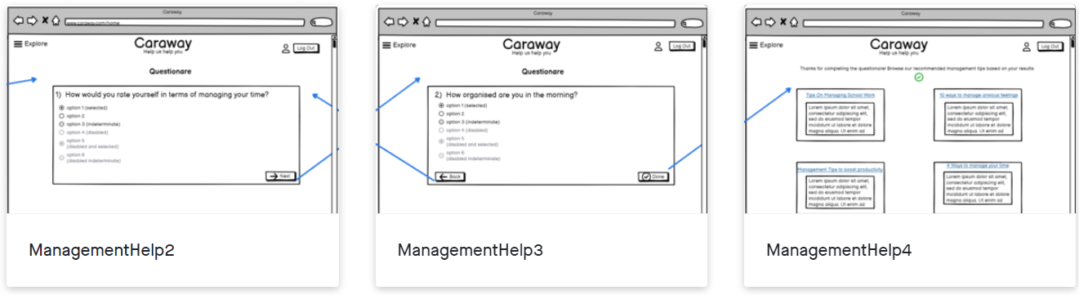

After:

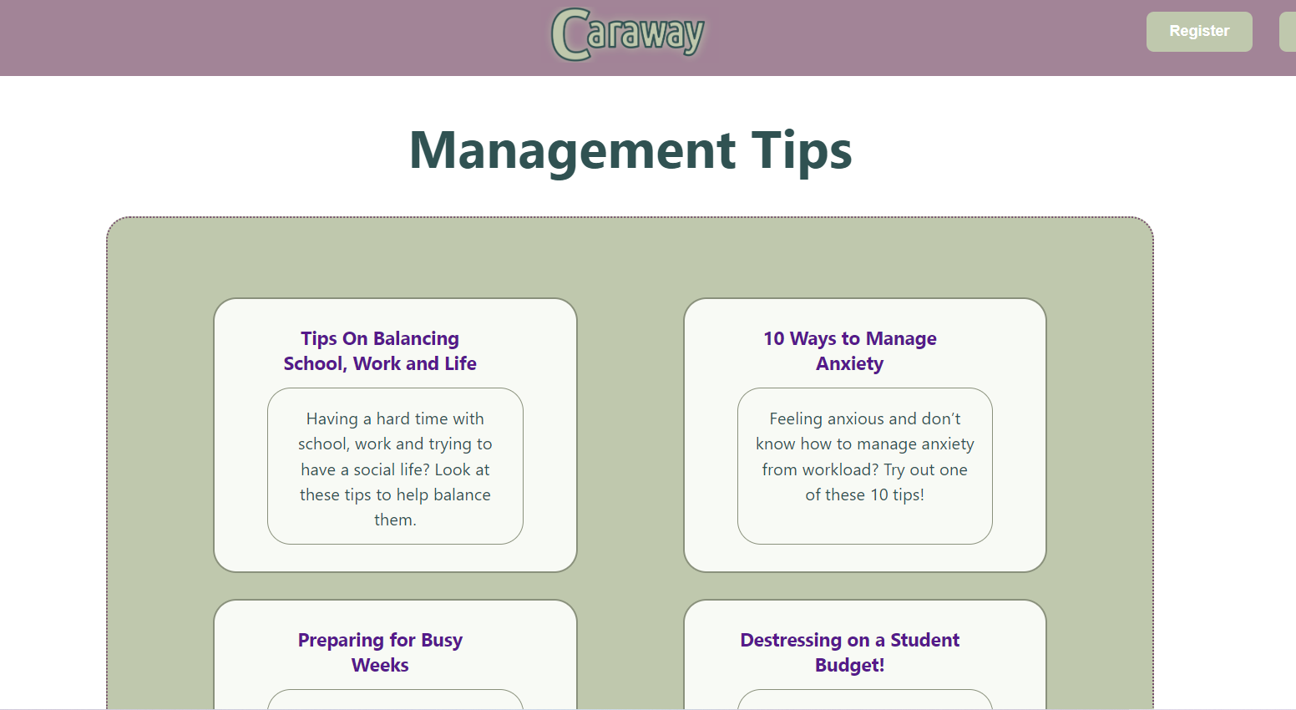

# User Testing

User testing is a technique that is used to evaluate a product by testing on users. Designers are able to get user feedback on the product and make adjustments on the product’s usability, functionality, and overall user experience. We tried to conduct think-aloud usability testing where the designer plays the role of a facilitator and several users try out the interface. The interface does not change between users. By conducting this kind of testing, our team was hoping to uncover any flaws or improvements we could make in our design. This would help better with increasing the impact and usability of our interface since users would be able to smoothly navigate between different pages.

## Participants

We selected users that were female students at UIC mainly because the product/website targets female students that need assistance with stress management. There are stress management tips and therapy sessions available to female students to help them cope with education. A total of 6 users were asked to participate in the user testing.

## Method

In order to conduct a successful user testing, our team followed these steps:

1. We first set up and prepared the interface on inVision so the users could work on our interface using a high fidelity prototype. We also prepared a list of tasks we wanted the users to complete.
2. We then introduced the think aloud user testing we were planning on conducting on eligible female students.
3. We then introduced the system/interface and described what is its purpose.
4. We then explained a task and asked them to complete it.
5. As they worked on the task we listened to how they were thinking aloud and observing their actions.
6. We then analyzed the patterns of breakdowns and which parts of the interface can be adjusted to better cater to our users.
7. We then repeated steps 4-6 for each of the remaining tasks.
8. We then asked the user to give feedback using the questionnaire we had created on Google Forms.

The users were asked to complete the following tasks and the successful list of actions are also mentioned:

* Task 1: Create an new Account
  + Success: **Home** -> Register -> Scroll Down -> Create an Account -> **Home Page**
* Task 2: Schedule a Therapy Appointment
  + Success: **Home** -> Explore -> Meet Therapists -> Scroll Down -> Scroll Down -> Book Session -> Submit -> **Confirmation Page**
* Task 3: Look into Family Financial Aid Programs
  + Success: **Home** -> Explore -> Financial Aid Programs -> Scroll Down -> Family Discount -> **ends here on invision, but slides have the screens needed**
* Task 4: Find information on Stress Management Tips
  + Success: **Home** -> Explore -> Management Tips -> Next -> Next -> Next -> Done -> **10 Ways to Manage Feeling Anxious**

The data logging method that was used was a user evaluation sheet which was created using Google Sheets. The following parameters were recorded: User ID, Task ID, Success, Failure, Amount of time (in seconds), behaviors, intention, and error. Each of the users were assigned a unique user ID to keep track of each of the users’ feedback. Each of the tasks was assigned a unique task ID so the feedback from each of the users was recorded under the appropriate task ID. The success and failure columns indicated whether each of the tasks performed by each of the users was a success or a failure. The amount of time in seconds showed how long each of the tasks took to complete. The behaviors recorded what the actions the user was doing. It was what the facilitator could see the user doing. However, the intention column recorded what the user was trying to accomplish. This was done through the think aloud protocol. The error column recorded the errors the user made for each of the tasks based on what was wrong with the interface. We recorded how long it took the users to complete each task. We recorded their behaviors step-by-step as they worked on the task, whether they were wrong or correct to track their thinking. We made sure to include what they intended to accomplish in each task, as well as their actual actions. At the end of the study, we asked the users to complete a questionnaire and provide their suggestions and feedback on the interface. Based on the feedback we received, we discovered some pain points in our design, and we were given ideas on how to improve those pain points.

The following questionnaire was used:

<https://forms.gle/wVA8vikAZmK1HCQS9>

[User - Testing Evaluations](https://docs.google.com/spreadsheets/d/1KQeQ9n31_HNstfcNp8FEL6ZZFmSV55vC/edit?usp=sharing&ouid=116101322438912413979&rtpof=true&sd=true)(for **facilitators**: while they’re completing tasks)

[User - Testing Questionnaire](https://forms.gle/ci9tJrfno8Btbruk8)(for users: after they’re done with all tasks)

## Findings

Questionnaire summary:

Majority of the users would want to use the website frequently. 66% of the users did not find the website complex at all, while the remaining 34% rated complexity level 2 out of 5. 66% of the users found the website very easy to use, while the remaining 34% rated the easy level 4 out of 5. 66% of the users said they would not need support of a technical person while the remaining users said they would need minimal assistance. Most users found the tasks very straightforward. However, some of the suggestions for improvement were made regarding the create account feature. A user found it confusing to differentiate between creating an account and logging into an existing account. Another suggestion was to remove the questionnaire in the beginning if the management tips section or just make it optional.

Data logging sheet summary:

Most users took around 40-50 seconds to complete the task. Most of the users found the scheduling appointment task difficult. Having only one button at the end of the therapists’ introductions to schedule an appointment was often confused with that button being only for the last therapist. However, it was a general scheduling button that can be used to schedule an appointment with any therapist. Another error or confusion regarding the management tips questionnaire. Most users were confused as to what was the purpose of the questionnaire. Also, after filling out the questionnaire, the website only displayed certain articles based on the users’ responses. However, the users wanted to be able to access all the articles. Also, some users wanted to know if the therapists are available in person or online when reading each of the therapists’ descriptions.

Basic statistics of your evaluation and a summary of results:

Although most users were able to successfully complete all the tasks right away, there were some suggestions they made that would improve their user experience. We decided to incorporate their feedback in our final design to better cater to user goals.

## Design Changes

The improvements that will be made for the final implementation are:

1. Remove the questionnaire in management tips.
2. Make all the articles available to the users.
3. Have a separate ‘book session’ button for each of the therapists.
4. Mention if each of the therapists are available in person or online in the therapists’ descriptions.

**Top 5 user needs:**

**1) Personal support system consisting of productive conversation around stress and stress management**

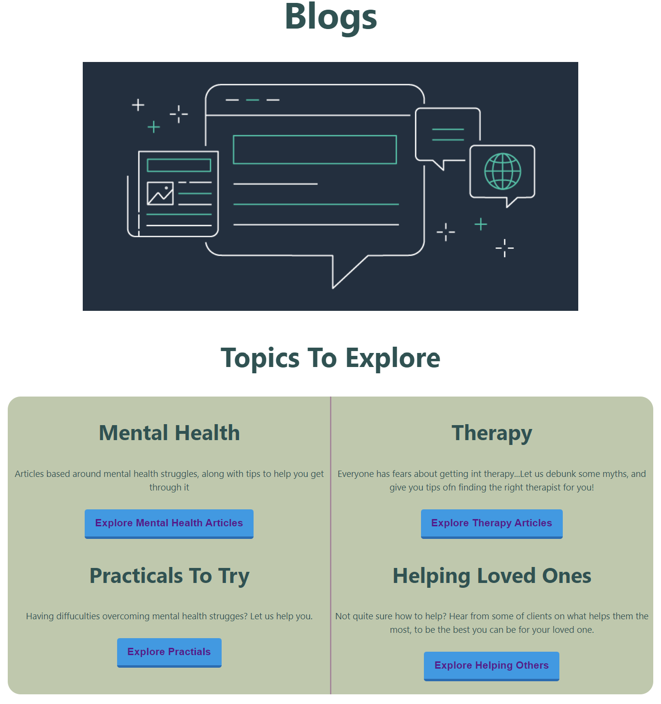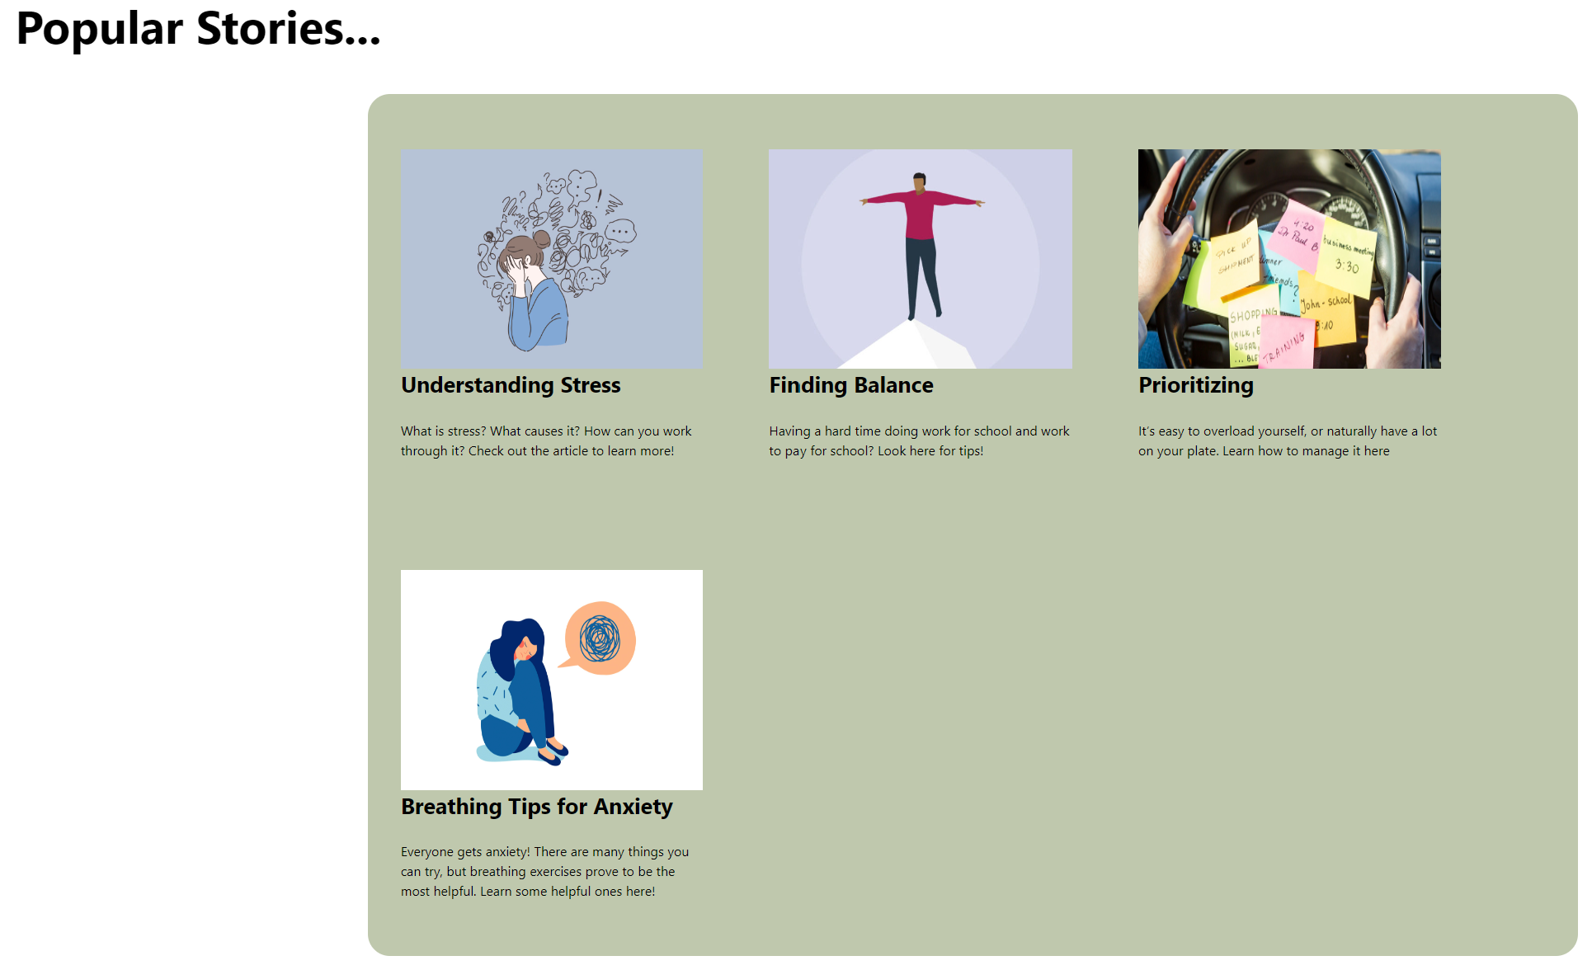

The blogs page encourages users and the community to contribute to a productive conversation around stress and stress management.

**2) Affordable/free and convenient therapy sessions**

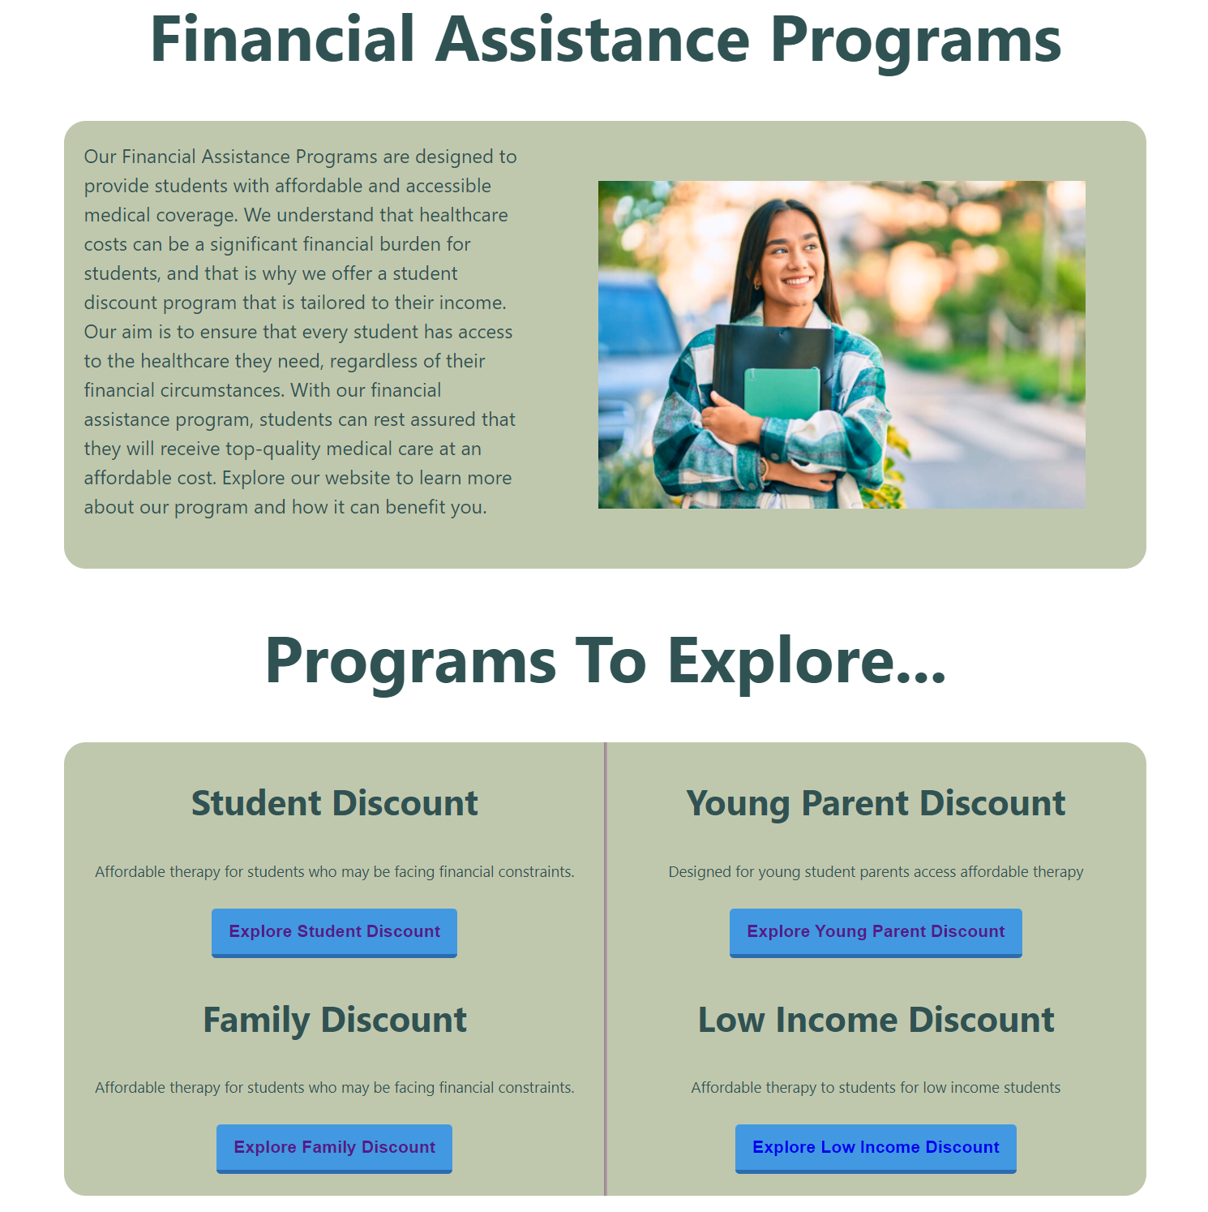

We included a financial assistance page that displays all the financial assistance programs Caraway offers to make therapy sessions more affordable.

**3) Hobbies which healthily decrease stress**

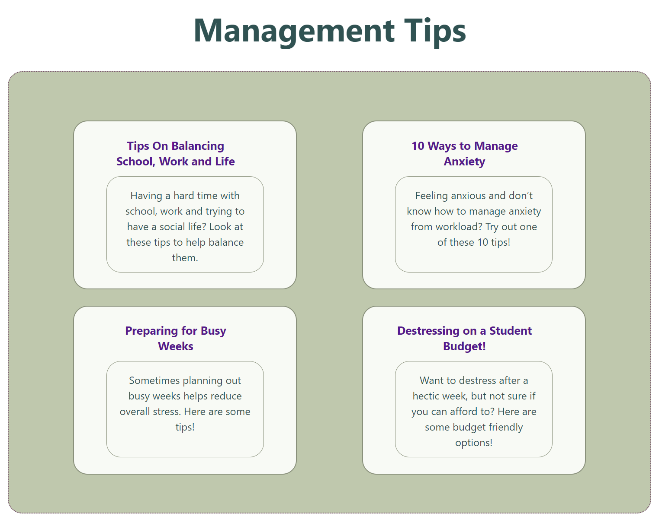

The management tips page includes tips for hobbies, school, work and various other options that can help a user make healthy lifestyle choices.

Change a) which was ‘Remove the questionnaire in management tips.’ deals with user need #3 where users prefer viewing the tips right away instead of having to complete a questionnaire.

Change b) which was ‘Make all the articles available to the users.’ was related to change a) where the users wanted to be able to view all the articles regardless of the choices they made in the questionnaire. After removing the questionnaire we displayed all the helpful articles so users can browse through them freely.

**4) Option between in-person and online**

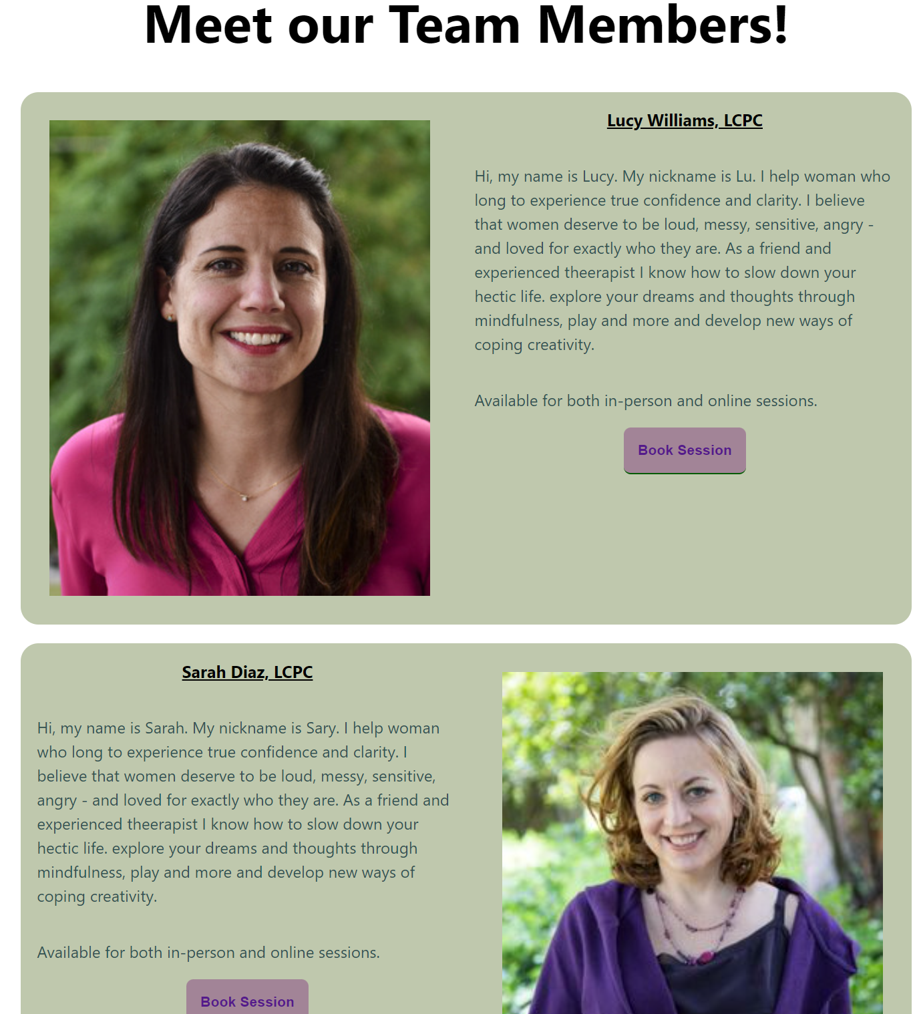

On our ‘Meet Therapists’ page, users can read about the therapists and check if the therapist offers in-person and/or online sessions. Each therapist can have their own availability.

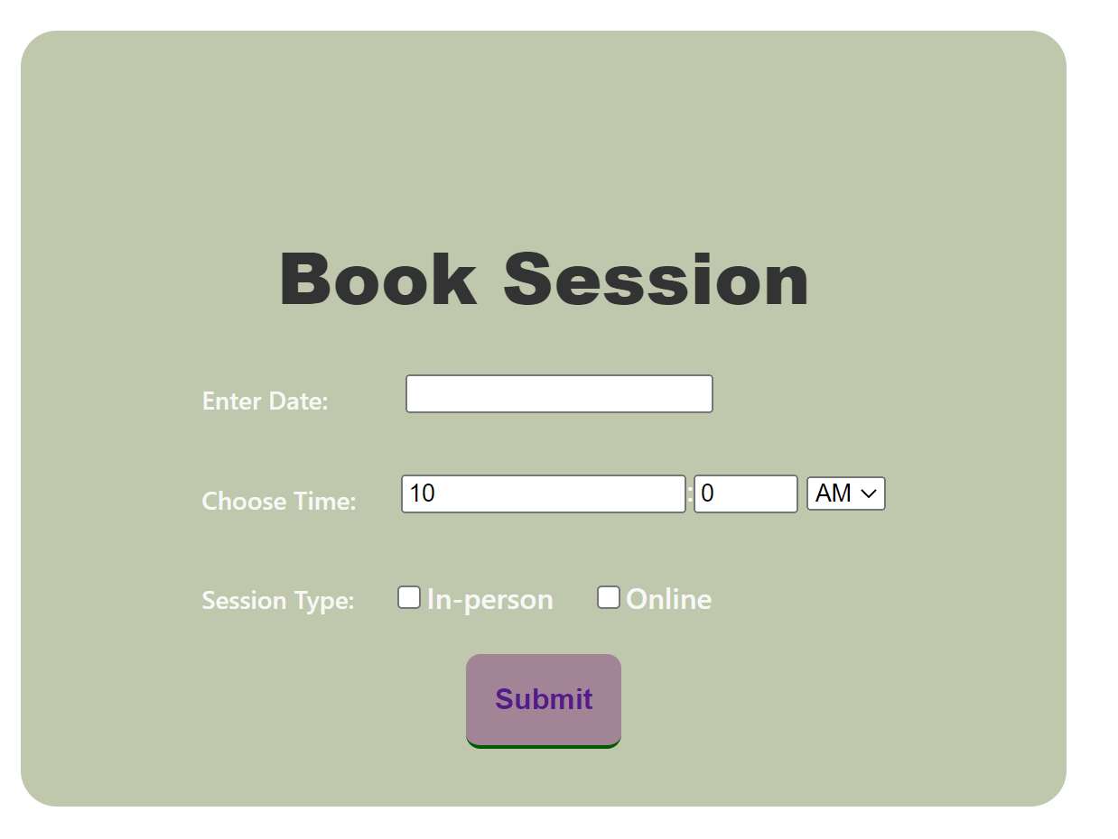

Changes c) which was ‘Have a separate ‘book session’ button for each of the therapists’ and changes d) which was ‘Mention if each of the therapists are available in person or online in the therapists’ descriptions’ is related to user need #4 where they can book in person or online appointments with the therapists of their choice. Initially there was only one book session button at the end which was confusing users since they assumed it was only for the last therapist. By having a book session button after each therapists’ description and availability, the users can make their in-person or virtual appointment freely.

**5) Ability to see reviews for Caraway**

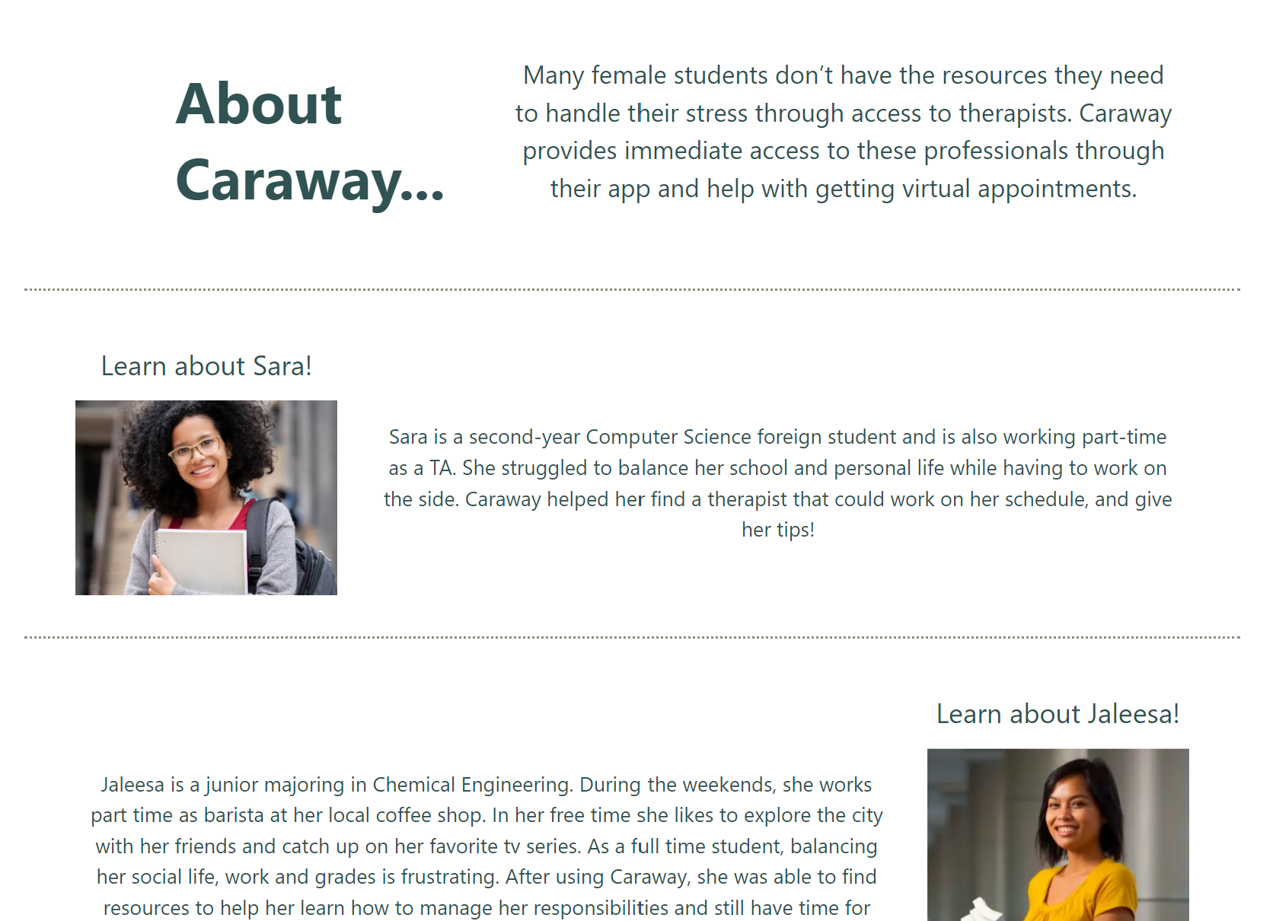

The home page includes reviews from past users that other users can view.

# UI Implementation

UI implementation is the process of translating the user interface design into a functional user interface that users can interact with. It takes the high fidelity prototype and turns it into code utilizing front-end development tools such as HTML, CSS, Javascript or React. This section will discuss the frameworks we used, how we implemented them and any problems we encountered.

For our user interface we utilized React and CSS for styling. Our implementation follows the Model-View-Controller architecture, which involves breaking down the application into smaller, reusable components that manage their own state. This approach enables easy reuse of components, such as the NavBar and Footer components, throughout the application.

To handle user input, we utilized states and events. For example, when a user fills out a form for login or registration, we track their input using state. We also used event handlers to detect when a user clicked on the calendar to book an appointment. These techniques helped us to efficiently manage user interactions within the application.

During the implementation of our interface, we encountered a few issues that potentially impacted the usability of our application. One issue we faced was related to scrolling behavior when navigating to specific financial aid pages. React saves the position of the scrollbar from the previous page, which causes the page to automatically scroll to the bottom, frustrating users who then had to manually scroll back to the top. To address this, we implemented a constant variable using the 'window.scrollTo(0, 0)' method, which ensures that the page always loads at the top.

Another implementation issue we encountered was related to user registration. There was no error checking in place to ensure that users enter all required fields, which meant that users could register and log in without providing necessary information. To solve this problem, we implemented 'useState' hooks for each required field to check for errors. For example, we checked that the email field had the correct format and if the user clicked submit without filling out all required fields, a pop-up alert would appear on the screen, indicating that the form was incomplete.

# 

# Appendix A: Discussion Guide

**Discussion Guide**

**Safiya Mustafa, Hina Khalid, Ada Pici, Charlotte Andry**

| **Focus Statement**  **(include research context and target users)** | Understand how female UIC students deal with stress management and what resources can assist them with finding therapists that fits their personal preferences and needs. Identify constraints or barriers they face when reaching out to therapists. |
| --- | --- |
|  |  |
| **Discussion Guide** |  |
| * **Introduction** | Hello, I’m Charlotte, and today we’re here to do a focus group for our in-class project. This focus group is to discuss how female UIC students deal with stress management and what resources can assist them with finding therapists.  I will lead the conversation about your experiences dealing with therapists and stress management, while other team members record your answers.  We will also be audio/video recording this focus group if that is fine with you so we can refer to it later. All the records will be kept confidential.  This focus group will be 50 minutes long. Feel free to share your experiences and thoughts. Do you have any questions for me before we get started? |
| * **Key demographic questions** | 1. Names  2. Gender  3. Age  4. Year/Major  5. What’s one way you like to handle stress? |
| * **Warm-up questions (factual answers)** * **(opening up the floor…)** | 1. What is a tactic you use to manage stress?  2. What are ways you like to make sure you don’t burnout or get over worked?  3. What’s one thing you’re looking forward to this week? |
| * **Main questions (open-ended discussions)** | -How much does your education contribute to your stress?  -tell us about a time you felt the most stressed. How did you manage your stress? What’s your process? Who did you speak to?  - When’s the last time you felt like you needed to reach out to someone because of how stressed you felt?  - How does your social circle impact your stress levels?  **For those who have a therapist:**  - How do you go about looking for a therapist? What characteristics do you look for/consider?  - When do you think it’s a good time to see your therapist about stress?  - Do you prefer group sessions over individual sessions? Why or why not?  - What has worked for you better in the past, online or in-person sessions? If you don’t have experience maybe you can make this comparison using your in-person vs online classes experience.  **For those without a therapist:**  - Have you ever thought about it?  - Why have you decided to refrain from having a therapist?  - Do you feel your needs are being met without a therapist?  - What other tactics do you use that help without a therapist? |
| **Design Probe(s)** | - different strategies for stress management(which ones do they think are more effective?) |

# 

# 

# Appendix B: Transcripts and Signature Sheet

**Transcript**

Facilitator: [Charlotte Andry](mailto:candry2@uic.edu)

Transcribers: [Safiya Mustafa](mailto:smust3@uic.edu), [Hina Khalid](mailto:hkhali21@uic.edu), [Ada Pici Nieves](mailto:apici2@uic.edu)

**What’s one way you like to handle stress? Avoiding what is stressing me out, not thinking about it.**

Sania: Gets away from work and plans out her day in advance.

Litzy: Likes going on walks, listening to music and podcasts.

Diya: I like to write down what is stressing me out and then do a hobby like reading a book.

**What’s one thing you’re looking forward to this week?**

Micah: Paint night, superbowl Sunday

Charlotte: Galentine’s day

Nayeli: Looking forward to the goals she has set for herself.

Micayla: Friday since it is the end of the week. No plans, just relax from all the work this week.

Litzy: Reading the book Tomorrow, Tomorrow, excited to finish it.

Diya: I am looking forward to seeing my friend because it is her birthday on Friday.

**-How much does your education contribute to your stress?**

Sania: Main source of stress

Micah: She is not working so it is the only source of stress

Xiao: Recently tested COVID-19 positive, so she is behind on school work. Has a lot of assignments due and multiple assignments are being assigned.

Litzy: Education was the top reason for stress, balancing education and a social life was stressful because prioritizing school was important. A lot of course work and wanting to do well was stressful.

Diya: A lot, i get stressed out because of grades and due dates and the workload of school.

**-Tell us about a time you felt the most stressed. How did you manage your stress? What’s your process? Who did you speak to?**

Micah: Week 3 Spring semester: Speech assignment for communication class. She was not supposed to read from note cards. To manage: she practiced a lot and did breathing exercises. Also, do not focus only on people looking at you. Everyone’s on the same boat so do not stress about what people are thinking.

Diya: I was the most stressed last spring when I had school and I worked 20 hrs a week and commuted 3 hrs a day. I managed this by going to the counseling center and talking to them every week. I would write a to do list every day and work my way through it by taking one task at a time. I spoke to the counseling team once a week and to my friends a lot.

Micayla: Fall 2022 semester: had a lot of semesters. Pull 3 all nighters and stay awake to deal with it. Previously in RA, which does add to the stress. Lives where she works.

Xiao: To manage, she starts early on her assignments and reaches out to TAs for help.

Litzy: When she was undecided about her major, didn't know what to do. She talked to her advisor to talk about academics. She also talked to her sister to guide her since she knows her really well. Having those conversations helped her decide what she liked.

**- When’s the last time you felt like you needed to reach out to someone because of how stressed you felt?**

Micah: Talked to mom last week about school work. Although her mom understood what she was going through, Micah’s stress remained the same. She feels motivation comes from within and only reduces it if she gets the work done.

Xiao: She doesn’t want to talk to family or friends because when she did tell her mom, her mom said she needs to work hard since she is just a student. Her mom wasn’t able to understand where she was coming from so now she doesn’t tell her mom now.

Litzy: When she was applying to jobs she was getting rejections, speaking to her sister helped her because she had someone that listens.

Diya: Last week, I was stressed about a decision I needed to make so I talked to my friend about it.

**For those without a therapist:**

**- Opinion on therapists:**

Xiao: Would not go because it takes time to go there. You might end up feeling better mentally, but the amount of work would still not go down which would keep stress levels the same.

Micayla: No time to go there, so therefore a therapist would be unproductive since work would not decrease. Mentally you might feel better, but physically you would still feel unwell.

Sania: Better to talk to friends and family since therapists are costly. Also, surround yourself with people that can relate to you and give you a support system.

Litzy: Went to therapy sophomore and junior year. Going to a therapist helped her understand what she has, she was able to diagnose with anxiety and adhd. Knowing her diagnosis helped her understand herself and make school easier for herself.

**What if therapist services are free?**

Sania: depends on the kind of stress. If it is related to friends and family where you need an outsiders’ perspective or you don’t want to burden others. Would not go for school related stress.

Micah: No, not for school because she knows the only way to reduce school stress is complete the assignments. She would go for personal therapy or vent to someone.

Micayla: She would go for something deeper than school.

Litzy: Yea I only went to therapy because it was a free resource from my university.

Diya: Yes I think stress management therapy is helpful - I tried it last spring. I went because counseling is free for 15 sessions as a student. It would be great if therapist services were free or at least a lower cost than it is.

**What characteristics do you look for in therapists?**

Micah: Female and same race, so they can understand. Also, wants the therapist to challenge and encourage her. She wants someone who will not just listen, but will also follow-up and guide her.

Sania: Woman and someone that was recommended. Might not want to go to someone who might share her details with others.

Micayla: Will look for good reviews and trial sessions.

Litzy: Similar background as her. Wanting a first-gen POC and a woman. The struggles they went through are similar to hers to better understand her.

Diya: I look for a therapist that is kind, understanding, non judgmental, and able to give logical advice when I am thinking too emotionally.

**Online or in-person?**

Sania: In-person since it is easier to get feelings across. Can also communicate with body language. There is better bonding and comfort.

Micah: In-person because it is easier to get feelings across. Can also communicate with body language. There is better bonding and comfort. Also, you can’t control the environment and might not want to open up and be honest if people are present.

Litzy: It wouldn’t matter. Both are good options for her. Face-to-face communication is a good experience but online wouldnt be a bad option either.

Diya: I prefer either, online is nice only if you have a space that you can be alone at.

**Participant Signature Sheet**

**Submitted by:**

**7: Ada Pici, Safiya Mustafa, Charlotte Andry, Hina Khalid**

**Participants:** By signing this form, you acknowledge that you have participated in a focus group or user test for the above group related to the above course on the date indicated below.

| Printed Name of Participant | Signature of Participant | Date of Participation | Printed Name of Participant | Signature of Participant | Date of Participation |
| --- | --- | --- | --- | --- | --- |
| Xiao Chen | Xiao Chen | 02/06/23 | Diya Patel | Diya Patel | 02/06/23 |
| Micah Greene | Micah Greene | 02/06/23 | Litzy Bucio | Litzy Bucio | 02/06/23 |
| Nayeli Solis | Nayeli Solis | 02/06/23 |  |  |  |
| Micayla-Allene Brent | Micayla Brent | 02/06/23 |  |  |  |
| Sania Khaja | Sania Khaja | 02/06/23 |  |  |  |

| *Group Members: please initial below to indicate that your group members acknowledge that you are aware that you are bound by UIC’s honor policy in letting participants sign this form only if they have actually participated in a focus group or user test for the class as required.* | | | | | |
| --- | --- | --- | --- | --- | --- |
| (group members’ initials) | SAM | CPA | HK | AP |  |

# 

# Appendix C: Affinity Diagram

**Affinity Diagram**









# 

# Appendix D: Annotated High-Fidelity Prototype

1) Home -> Menu -> Management Tips -> External Article

# 



2)Blogs -> Topical Articles -> Popular Articles -> External Article



3) Therapist Bios -> Booking a Session 

4) Therapist Bios -> Booking a Session





# Appendix E: User Testing Script

**Demo User Test Script**

| - **Introduction** | Hello, I’m [**name**]. Today we are going to test our prototype for our website Caraway, which is focused on providing affordable therapy and stress management options for college women. We will also be recording or taking notes of this user test to refer to later. All the records will be kept confidential. This user test will be no more than **10** minutes long.  This app is an early prototype of a design concept. You’re helping us by trying out this product in its early stages. We’re looking for places where the product may be difficult to use. If you have trouble with some of the tasks, it’s the product’s fault, not yours. Don’t feel bad, that’s exactly what we’re looking for. If we can locate the trouble spots, then we can go back and improve the product. **Remember, we’re testing the product, not you.** Do you have any questions for me before we get started? |
| --- | --- |
| - **Task 1: Account Creation** | **Task description**: Create a new account using our website  **Task deemed completed**: Presses the “Create Account” button and returns to the Home Page |
| - **Task 2: Book Session** | . **Task description**: Schedule a therapy session  **Task deemed completed**: Sees the confirmation page for the appointment with the “Done” button |
| - **Task 3: Financial Aid Programs** | . **Task description**: Look into the Young Parent Financial Aid Program  **Task deemed completed**: Looking at the Financial Aid Programs page with the list of different program options |
| - **Task 4: Find Management Tips** | . **Task description**: Use our website to find some stress management tips  **Task deemed completed**: Looking at the 10 Tips for Stress Management article |
| **Reminders and Prompts:** | -mention there’s **no ability to typ**e in this version, and to scroll down you’ll need to **click on the bottom of the scroll bar**  - if the user stops talking for more than 10 seconds, prompt them: “Please remember to think aloud.”  - if a user can’t figure out what to do and seems unable to make progress for more than 30 seconds, prompt them: “Can you tell me what you are trying to do?”  - if the user can’t figure out what to do and seems unable to make progress for more than 90 seconds, end the task and move on to the next one: “Ok, thanks for giving this a try. Let’s move on to the next task.” |

# 

# Appendix F: Data Logging Sheet

| **User ID** | **Task ID** | **Success** | **Failure** | **Amount of time (in seconds)** | **Behaviors** | **Intention** | **Error** |
| --- | --- | --- | --- | --- | --- | --- | --- |
| UI- Ant | 1 |  | X | 2:15 | Register |  |  |
| UI- Ant | 1 |  |  |  | Trying to type name | give input to the prototype | no input is taken |
| UI- Ant | 1 |  |  |  | trying to go to the next page | looking for a "next" button | there is no next button, only a scroll bar |
| UI -Ant | 2 | X |  | 1:23 | explore menu | looking for option to find therapists |  |
| UI -Ant | 2 |  |  |  | meet therapists | going through looking for more options to book therapists |  |
| UI -Ant | 2 |  |  |  | scrolling | going through looking for more options to book therapists | touch point was messed up |
| UI -Ant | 2 |  |  |  | meet team | going through looking for more options to book therapists |  |
| UI -Ant | 2 |  |  |  | book | trying to book a session |  |
| UI -Ant | 2 |  |  |  | submit | confirming session |  |
| UI -Ant | 2 |  |  |  | done | return to home page |  |
| UI - Ant | 3 | X |  | 1:03 | explore menu | find info on fap |  |
| UI - Ant | 3 |  |  |  | fap |  |  |
| UI - Ant | 3 |  |  |  | scroll |  |  |
| UI -Ant | 4 | X |  | 2:32 | explore menu |  |  |
| UI -Ant | 4 |  |  |  | management tips |  |  |
| UI -Ant | 4 |  |  |  | trying to give input |  |  |
| UI -Ant | 4 |  |  |  | next |  |  |
| UI -Ant | 4 |  |  |  | next |  |  |
| UI -Ant | 4 |  |  |  | next |  |  |
| UI -Ant | 4 |  |  |  | done |  |  |
| UI -Ant | 4 |  |  |  | balancing school work | confused on how to find tips |  |
| UI -Ant | 4 |  |  |  | scroll | confused on how to find tips |  |
| UI -Ant | 4 |  |  |  | Why is this happening? | confused on how to find tips |  |
| UI -Ant | 4 |  |  |  | website | confused on how to find tips |  |
| UI -Ant | 4 |  |  |  | next article | confused on how to find tips |  |
| UI -Ant | 4 |  |  |  | website | confused on how to find tips |  |
| UI -Ant | 4 |  |  |  | subscribe | confused on how to find tips |  |
| UI -Ant | 4 |  |  |  | exple | confused on how to find tips |  |
| UI -Ant | 4 |  |  |  | managem | confused on how to find tips |  |
| UI -Ant | 4 |  |  |  | all the way through | confused on how to find tips |  |
| UI -Ant | 4 |  |  |  | 10 management tips |  |  |
| UI -Ant | 4 |  |  |  | subscribe |  |  |
| UI -Ant | 4 |  |  |  | confirmation |  |  |
| U5 | 1 | X |  | 20 | clicked on register button | Register |  |
| U5 | 1 |  | X |  | tried to type to register | Enter inputs | not able to enter name |
| U5 | 1 |  | X |  | tried to scroll | go down to next page | not able to use scroll |
| U5 | 2 | X |  | 43 | user tried to login first | login |  |
| U5 | 2 | X |  |  | clicked on explore and meet therapist | Schedule Appointment |  |
| U5 | 2 | X |  |  | clicked on book session | Schedule Appointment |  |
| U5 | 2 |  | X |  | clicked on calendar | Schedule appointment | expected a calendar pop up |
| U5 | 3 | X |  | 30 | clicked on explore page | find financial aid programs |  |
| U5 | 3 | X |  |  | clicked on financial assistance programs | find financial aid programs |  |
| U5 | 4 | X |  | 25 | clicked on explore | find management tips |  |
| U5 | 4 | X |  |  | went to management tips | find management tips |  |
| U5 | 4 | X |  |  | clicked through the quiz | find management tips |  |
| U5 | 4 | X |  |  | clicked on article | find management tips |  |
| U6 | 1 | X |  | 20 | clicked on register |  |  |
| U6 | 1 | X |  |  | clicked on explore |  |  |
| U6 | 1 | X |  |  | clicked on create account |  |  |
| U6 | 2 | X |  |  | clicked on meet therapist |  |  |
| U6 | 2 | X |  |  | scrolled down |  |  |
| U6 | 2 | X |  |  | clicked on create appointment |  |  |
| U6 | 3 | X |  | 10 | clicked on explore |  |  |
| U6 | 3 | X |  |  | clicked on programs |  |  |
| U6 | 4 | X |  | 15 | clicked on explore menu |  |  |
| U6 | 4 | X |  |  | went to management tips |  |  |
| U6 | 4 | X |  |  | clicked through the quiz |  |  |